BAB 1
SURAT AKUAN PENYEBUTHARGA

LEMBAGA PEMBANGUNAN PELABURAN MALAYSIA
TINGKAT 14, MIDA SENTRAL
NO. 5, JALAN STESEN SENTRAL 5
KUALA LUMPUR SENTRAL
50470 KUALA LUMPUR.

SEBUT HARGA MIDA BIL. 38/2025
SEBUT HARGA BAGI PEROLEHAN PEMBINAAN PAVILION MIDA DAN RAKAN STRATEGIK UNTUK PROGRAM CENTRAL REGION’S INITIATIVE FOR MIDA FLAGSHIP EVENT
Kepada:

Penyebutharga-penyebutharga,

Borang ini hendaklah dikembalikan bersama-sama dengan JADUAL HARGA di dalam SAMPUL SURAT BERLAKRI

SURAT AKUAN PENYEBUTHARGA

Kepada:

Ketua Pegawai Eksekutif
Lembaga Pembangunan Pelaburan Malaysia
MIDA Sentral
No. 5, Jalan Stesen Sentral 5
Kuala Lumpur Sentral
50470 Kuala Lumpur.

Tuan,

SEBUT HARGA MIDA BIL: 38/2025

SEBUT HARGA BAGI PEROLEHAN PEMBINAAN PAVILION MIDA DAN RAKAN STRATEGIK UNTUK PROGRAM CENTRAL REGION’S INITIATIVE FOR MIDA FLAGSHIP EVENT

Di bawah dan tertakluk kepada Arahan Kepada Penyebut harga, saya yang menurunkan tandatangan di bawah ini adalah dengan ini mengambil bahagian sebutharga dan menawarkan untuk melaksanakan perkhidmatan di atas mengikut penentuan spesifikasi yang ditetapkan di dalam Dokumen Sebut harga.

2. Saya yang menurunkan tandatangan di bawah ini bersetuju menerima serta mematuhi dan terikat dengan semua Syarat-syarat Kontrak dan Spesifikasi Sebut harga ini dan bersetuju di atas harga yang ditawarkan RM……….............. sebagai asas perkiraan bagi pembayaran perkhidmatan yang telah dipesan oleh Lembaga Pembangunan Pelaburan Malaysia.

3. Dengan ini juga telah difahami bahawa MIDA berhak menerima atau menolak sebarang sebut harga ini, sama ada harga yang ditawarkan rendah atau tinggi atau sama dengan sebut harga-sebut harga yang lain. Saya juga bersetuju untuk menerima kesemua atau sebahagian dari item-item yang ditawarkan dan sedia mengikut kehendak dan pertimbangan MIDA. Saya juga bersetuju bahawa harga sebut harga yang saya beri ini akan sahlaku (valid) dan tidak ditarik balik dalam tempoh sembilan puluh (90) hari dari tarikh tutup sebut harga dan tiada apa-apa syarat dikenakan selepas tarikh ditetapkan.

4. Selanjutnya saya bersetuju sekiranya sebut harga saya diterima, saya akan mengikat perjanjian kontrak serta memberi bon pelaksanaan dalam tempoh empat belas (14) hari dari tarikh terima surat tawaran dari MIDA, sekiranya diarahkan.

5. Saya juga mengesahkan, setelah menyemak sendiri iaitu semua dokumen yang digunakan untuk sebutharga ini adalah yang sebenar yang terdapat di dalam Dokumen Sebut harga.

Nama Penyebutharga | :
 |  |  |  | (Tandatangan Penyebutharga)
Alamat dan Cop Rasmi Syarikat | :
Tarikh | :
Nama Saksi | :
 |  |  |  | (Tandatangan Saksi)
Alamat | :

SURAT AKUAN PEMBIDA

SEBUT HARGA BAGI PEROLEHAN PEMBINAAN PAVILION MIDA DAN RAKAN STRATEGIK UNTUK PROGRAM CENTRAL REGION’S INITIATIVE FOR MIDA FLAGSHIP EVENT

(SEBUTHARGA MIDA NO. 38/2025)

Saya, ………...………............................................ nombor K.P. …………….................... yang mewakili syarikat ….……………………….…….……………………….................... nombor Pendaftaran syarikat …….…………………................................ dengan ini mengisytiharkan bahawa saya atau mana-mana individu yang mewakili syarikat ini tidak akan menawar atau memberi rasuah kepada mana-mana individu dalam MIDA atau mana-mana individu lain, sebagai sogokan untuk dipilih dalam sebutharga seperti di atas. Bersama ini dilampirkan Surat Perwakilan Kuasa bagi saya mewakili syarikat seperti tercatat di atas untuk membuat pengisytiharan ini.

2. Sekiranya saya, atau mana-mana individu yang mewakili syarikat ini didapati cuba menawar atau memberi rasuah kepada mana-mana individu dalam MIDA atau mana-mana individu lain sebagai sogokan untuk dipilih dalam sebutharga seperti di atas, maka saya sebagai wakil syarikat bersetuju tindakan- tindakan berikut diambil:

2.1 Penarikan balik tawaran kontrak bagi sebutharga di atas; atau
2.2 Penamatan kontrak bagi sebutharga di atas; dan
2.3 Lain-lain tindakan tatatertib mengikut peraturan perolehan Kerajaan yang berkuat-kuasa.

3. Sekiranya terdapat mana-mana individu cuba meminta rasuah daripada saya atau mana-mana individu yang berkaitan dengan syarikat ini sebagai sogokan untuk dipilih dalam sebutharga seperti di atas, maka saya berjanji akan dengan segera melaporkan perbuatan tersebut kepada pejabat Suruhanjaya Pencegahan Rasuah Malaysia (SPRM) atau balai polis yang berhampiran.

Yang Benar,

……….................…………..
Nama :
No. KP :
Cop Syarikat :

BAB 2

SPESIFIKASI TEKNIKAL & SKOP KERJA

PEMBINAAN PAVILION MIDA DAN RAKAN STRATEGIK UNTUK PROGRAM CENTRAL REGION’S INITIATIVE FOR MIDA FLAGSHIP EVENT

      - GENERAL INFORMATION

Duration : 11 – 12 November 2025

Venue : Royale Chulan Hotel, Kuala Lumpur

Hall/Booth : Taman Mahsuri, Ground Floor

Exhibition Area : 11,000 sqft

Layout Plan : As per attachment

Estimated Budget : RM 200,000.00

2. BACKGROUND

This initiative is a strategic effort to develop targeted industrial clusters within the Central Corridor (Wilayah Persekutuan, Selangor, Negeri Sembilan, and Melaka) to create a distinct regional identity, addressing the lack of precise cluster positioning as highlighted in the New Industrial Master Plan 2030 (NIMP 2030). It focuses on priority industries with high-growth potential, based on existing ecosystems and in direct alignment with national strategic priorities under NIMP 2030.

3. OBJECTIVES

The objectives of Central Region Initiative are:

- Strengthening the focus industry ecosystem by using an ecosystem-based approach.

- Developing and promoting investment through the direct involvement and cooperation of State Governments and the Federal Territories.

- Empowering local companies in terms of their capabilities and competitiveness within the global supply chain.

- Developing an efficient and skilled workforce, particularly in supervisory and technical (S&T) fields that meet industry needs. Creating opportunities for collaboration and linkages between large companies and small and medium-sized enterprises (SMEs) to enhance global competitiveness.

- Providing a strategic platform for all involved stakeholders to share information, explore collaborative opportunities, and build professional relationships. This platform will also facilitate communication, cooperation, and synergy among the stakeholders.

4. PROGRAMMES DURING EXHIBITION

The proposed programmes that will be undertaken during the exhibition are:

- Business Consultation
- Individual Meetings

5. WORKING PHASE FOR APPOINTED CONTRACTORS

The service will be carried out in three (3) phases as follows: -

i) Phase 1 - To carry out the concept and design of Pavilion
ii) Phase 2 - To Conduct Pavilion construction work
iii) Phase 3 – To Conduct Dismantle work of the all pavilions

Phase 1: Company MUST submit a concept and design by reference (item 5.1) before or on closing date of the quote process.

Phase 2: Concept and design approved will be used for the construction of the pavilion, which will start a day before the event date. For the construction work scope of the pavilion should refer (item 5.2).

Phase 3: Company must do the dismantle work of the all pavilions on the last day of event after 6pm.

5.1 CONCEPT AND DESIGN OF PAVILION (PHASE 1)

5.1.1 The concept should be modern, practical and clean.

5.1.2 The theme of the MIDA Pavilion is “Malaysia Your Profit Centre in Asia” & “Central Region – Innovating Industries, Connecting Markets”.

5.1.3 The pavilion should allow free-flowing traffic i.e. open concept.
- Exhibition Hall Pavilion
  - Construct and install 4 side pavilions for 4 states (16 x 16) with digital unit such TV or LED screen.
  - Construct and install Centre Court Pavilion for MIDA & MITI (20 x 20) with digital unit such TV or LED screen.
  - Construct and install 6 mini pavilions for strategic partners (16x16) with digital unit such TV or LED screen.
  - Construct a box-type lightbox arch measuring 8’ x 8’ complete with logo

5.1.4 The contractor must propose at least 2 designs. Each design may use MIDA primary and/or secondary colour schemes.

5.1.5 The design theme of the pavilion should depict/showcase:

5.1.5.1 Malaysian Central Region as an ideal location for investment;
and
5.1.5.2 Potray eco-friendliness and the quality of life in Malaysia

5.2 THE CONSTRUCTION OF THE PAVILION SHOULD INCORPORATE: (PHASE 2)

5.2.1 Prominent MIDA/State IPA’s/Strategic Partner logo signage with large format visuals (with hanging banners, if required);

5.2.2 One main poster/backdrop physical.digital with the tagline “Malaysia Your Profit Centre in Asia” and Central Region – Innovating Industries, Connecting Markets;

5.2.3 One poster/backdrop physical or digital with the tagline “MIDA Your First Point of Contact for Investments in Malaysia” and Central Region – Innovating Industries, Connecting Markets;

5.2.4 Custom-made information counter with storage compartment complete with internet facilities with two units laptop computers for MIDA representative;

5.2.5 Sufficient exhibit area to display 2 promotional posters or digital TV;

5.2.6 The contractor is to design, print and produce the difference of 2 graphics/posters as required. Content materials for graphics/posters (where available) will be provided by MIDA;

5.2.7 To provide suitable number of set of discussion table and chairs for each pavilions

5.2.12 Sufficient storage area for publications/exhibition materials;

5.2.13 Suitable shelves/racks or digital unit to display publications;

5.2.14 To provide 2 cartons of 230 ml bottled mineral water throughout the event;

5.2.15 Suitable flooring, whether wood, plastic laminate or carpet to blend with the overall concept;

5.2.16 Sufficient track lights or suitable forms of lighting to create the best ambience or aesthetic effect for selected areas e.g. exhibits area, discussion area, information counter and brochure displays area;

5.2.17 Sufficient and suitable furniture for e.g. bar stools with arm rest for the information counters, discussion tables and chairs, potted plants and waste paper baskets;

5.2.18 Sufficient power points for LCD TV, computers, spotlights etc.

6. WORK SCOPE
The scope of work in relation to the project includes the following:

6.1 To design the MIDA Pavilion in line with the objectives and theme of the exhibition, as well as to project Malaysia as a preferred location for investments;

6.2 To fabricate the exhibition area based on the design approved by MIDA;

6.3 The contractor should adhere to the requirements and specifications of the main organiser which is MIDA.

6.4 The Contractor shall prepare the actual pavilion design and the necessary specification or measurement of the visuals needed for the design.

6.5 The Contractor is required to familiarise with the exhibition halls before submitting the proposal. This includes the form and nature of the site: the details of the subsurface conditions; existing services; requirement of the relevant authorities having jurisdiction over the fairground; the construction of the pavilion; the extent and the nature of work involved and the materials necessary for the completion of the project; and the means of access to the site and in general. The contractor shall have obtained all necessary information, as to risks, contingencies and all other circumstances which may influence or affect the proposal.

6.6 To coordinate and supervise the construction of the MIDA Pavilion according to the approved design.

6.7 The contractor shall provide the timeline for the whole project.

6.8 The handing over of the pavilion must be in approved condition at least two days before the official opening (or other necessary arrangement).

6.9 To ensure the safety of the pavilion and its exhibits during the construction/assemble of the pavilion, during exhibition and tear-down/dismantling period.

6.10 The contractor shall have stand-by personnel on site during the fair for corrective /maintenance of the booths/pavilion.

6.11 The appointed contractor must provide the services of visual merchandiser to ensure the best possible for the MIDA Pavilion.

6.12 To be responsible for all shipping, forwarding, insurance coverage and customs clearance of all built-up items for the MIDA Pavilion, if required.

6.13 Other necessary requirements by MIDA from time to time (where applicable).

BAB 3 – JADUAL MAKLUM BALAS TEKNIKAL

REKABENTUK DAN PEMBANGUNAN PAVILION
- Syarikat perlu mengemukakan dua (2) cadangan rekabentuk struktur pavilion dalam format (hardcopy dan softcopy) untuk pemilihan dan semakan lanjut.

- Syarikat mencadangkan rekabentuk pavilion yang modular, mudah dibina dan sejajar dengan identiti jenama MIDA serta konsep lestari. Rekabentuk perlulah selari dengan garis panduan jenama MIDA yang dibekalkan dalam dokumen sebutharga.

- Penjenamaan rakan startegik dibenarkan dengan nisbah keterlihatan (visibility) 70:30 (70% MIDA, 30% rakan strategik)

BAB 4

- PENGALAMAN/PROFIL SYARIKAT

Senarai projek yang sama yang telah disiapkan dalam tempoh tiga tahun terakhir mengikut kronologi:-
No | Butiran Kontrak | Nama Pelanggan  dan Alamat | Jumlah  Kontrak (RM) | Tarikh Siap

- PROJEK YANG SEDANG DILAKSANAKAN

Senarai projek :-
No. | Butiran Kontrak | Nama Pelanggan & Alamat | Jumlah Kontrak (RM) | Tarikh Mula | Tarikh Dijangka Siap | % Kemajuan

BAB 5 – JADUAL MAKLUM BALAS HARGA
No. | Category | Description of Scope | Costs Price (RM)
1
2
Sub-total (RM)
8% SST (RM)
Grand Total (RM)

BAB 6

BUTIR-BUTIR PENYEBUT HARGA & MAKLUMAT KEWANGAN SYARIKAT

Syarikat perlu mengisi dengan lengkap semua seksyen dalam borang ini. Sekiranya ruang tidak mencukupi, maklumat boleh dikemukakan dalam kertas berasingan.
- MAKLUMAT AM

 | Nama Syarikat |  | :
 | Alamat |  | :
 | No. Telefon |  | :
 | No. Faks |  | :
 | Emel |  | :
 | Tarikh Pendaftaran/ Penubuhan |  | :
 | No. Daftar Syarikat / Perniagaan |  | :
 | Tempat Pendaftaran/ Penubuhan |  | :
 | Komposisi Pemegang Saham |  | :
No. |  | Nama Pemegang Saham |  |  | Jawatan | % Pegangan

  - Peratusan Penyertaan Bumiputera : ________ (%). (Sila kemukakan maklumat lanjut atau salinan sah pendaftaran sebagai Pembekal Bumiputera dengan Kementerian Kewangan).

  - Maklumat Pendaftaran Kementerian Kewangan

No. | No. Pendaftaran | No. bidang | Butiran / Keterangan | Tempoh Sah

Nota : Sila lampirkan salinan sijil pendaftaran.

  - Struktur Modal Syarikat :

- Modal Dibenarkan | :
- Modal Berbayar | :

B. KEWANGAN
- Ringkasan aset dan tanggungan berdasarkan akaun yang diaudit bagi tiga (3) tahun terakhir.
Tahun Kewangan: | 2022  (RM) | 2023  (RM) | 2024  (RM)
- Jumlah Aset
- Aset Semasa
- Jumlah Tanggungan
- Tanggungan Semasa
- Nilai Bersih
- Modal Kerja

    - Bank-bank Utama:

No. | Nama Bank & Alamat | Jenis Akaun
1.
2.
3.

    - Kemudahan Kredit (Jenis dan jumlah kredit yang boleh disediakan oleh syarikat:)

No. | Jenis Kemudahan Kredit | Bank/Institusi Kewangan | Jumlah (RM)
1.
2.
3.

Nota:
Penyata Bank bagi tempoh tiga (3) bulan terakhir hendaklah disertakan bersama-sama serahan borang sebutharga.

LAMPIRAN SEMAKAN


LEMBAGA PEMBANGUNAN PELABURAN MALAYSIA
SEBUTHARGA PEMBINAAN PAVILION MIDA DAN RAKAN STRATEGIK UNTUK PROGRAM CENTRAL REGION’S INITIATIVE FOR MIDA FLAGSHIP EVENT
SEBUTHARGA MIDA BIL: 38/2025

SENARAI SEMAK

Sila tandakan ( √ ) atau nyatakan maklumbalas bagi dokumen yang disertakan:

Bil. | Perkara / Dokumen | Semakan oleh Syarikat | Semakan oleh  MIDA
- 5 | Surat Akuan Petender
 | Surat Akuan Pembida
 | Maklumat SSM (Salinan sijil disertakan)
 | Berdaftar dengan SSM dan tempoh pendaftaran masih berkuatkuasa
 | - No. Sijil Pendaftaran (sila nyatakan)
 | - Tempoh Sahlaku Sijil Pendaftaran (nyatakan)
4. | Salinan Sijil Pematuhan Cukai (Tax Compliance Certificate - TCC) daripada Lembaga Hasil Dalam Negeri (LHDN)
5. | Maklumat pendaftaran dengan Kementerian Kewangan (MOF) (Salinan Sijil Akuan Pendaftaran dengan MOF disertakan)
6. | Syarikat berdaftar dengan Kementerian Kewangan (MOF) dalam kod bidang berikut (dan tempoh pendaftaran masih berkuatkuasa):  221305 – Perkhidmatan Kesenian/ Hiburan dan Pelancongan/ Penyediaan Pentas/ Pameran Pertunjukan, Taman Hiburan dan Karnival/ Pestaria.
 | - No. Sijil Akuan Pendaftaran (nyatakan)
 | - Tempoh Sah laku Sijil Pendaftaran (nyatakan)
 | - Sijil Akuan Pendaftaran Bumiputera (sijil disertakan, jika ada)
 | - Peratus Penyertaan Bumiputera (nyatakan, jika ada)
7. | Maklum balas Teknikal (Hardcopy & Softcopy)
 | - 3 mock-up cadangan rekabentuk
8. | Maklum balas Kewangan (Hardcopy & Softcopy)
 | - Tawaran Harga
 | - Penyata Kewangan untuk 3 tahun terakhir
 | - Penyata Bank untuk 3 bulan terakhir
9. | Lain-lain: Profil syarikat, contoh kerja-kerja yang seumpamanya.

PENGESAHAN OLEH MIDA
Jawatankuasa Pembuka Sebut Harga mengesahkan penerimaan dokumen bertanda kecuali bagi perkara bil. .......................................... (jika ada) :-

Tandatangan | : | .....................................................................................
Nama | : | .....................................................................................
Jawatan | : | .....................................................................................
Tarikh | : | .....................................................................................

Appendix I
LAYOUT PLAN


Appendix I/2

BRAND GUIDELINES (as at 11 November 2023)
Malaysian Investment Development Authority (MIDA) logo is an important part of our organisation’s valuable intellectual property. Correct usage of MIDA’s logo is integral to developing and maintaining a consistent brand image and message about our organisation. The monogram and logotype that comprise our corporate logo have been carefully designed. Do not redraw or alter the artwork in any way. Any authorised usage of MIDA logos must comply with MIDA's requirements.

Any use of MIDA's logo must be (a) truthful, fair, not misleading, and (b) comply with MIDA's requirements, which may be modified at any time at MIDA's sole discretion. Always use the logo in the manner intended by MIDA. Do not alter them in any way. Do not make puns out of them or portray them negatively.

- Vision

Malaysia as the pre-eminent preferred investment destination.

- Mission

We build dynamic and sustainable investment ecosystem.

- The Master Logo


- Logo Rationale

 | 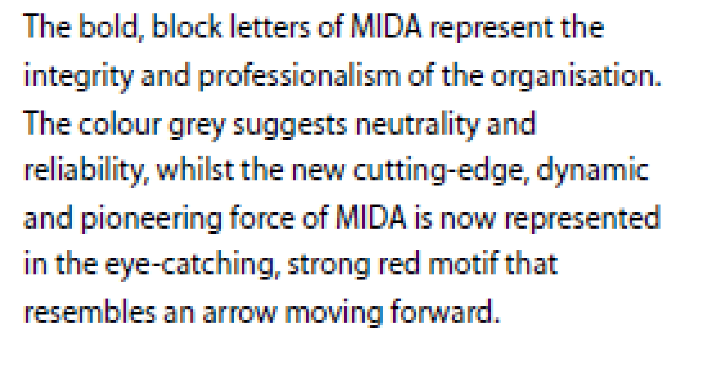
- Master Logo Elements
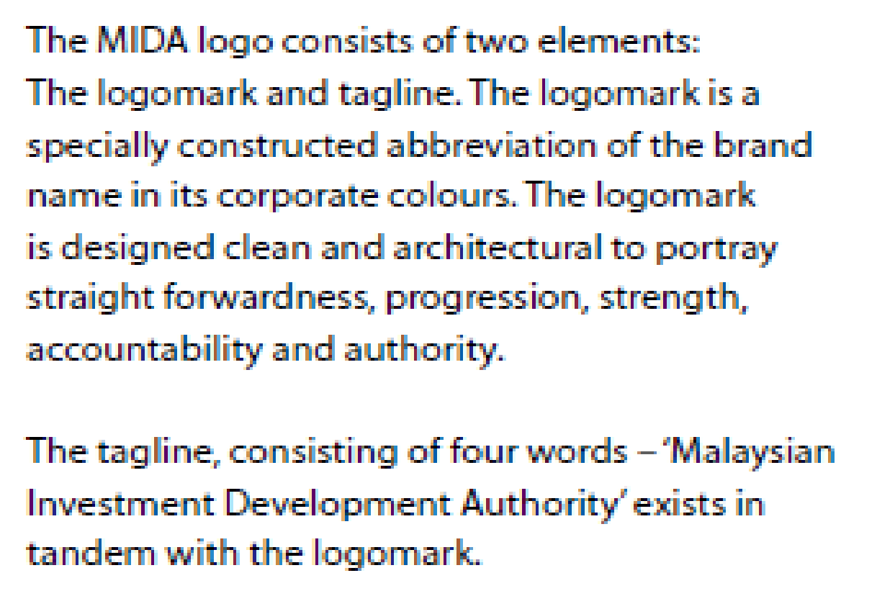

- Colour Code (Red: Pantone 1797U ; Grey: Pantone Cool Grey 11U)

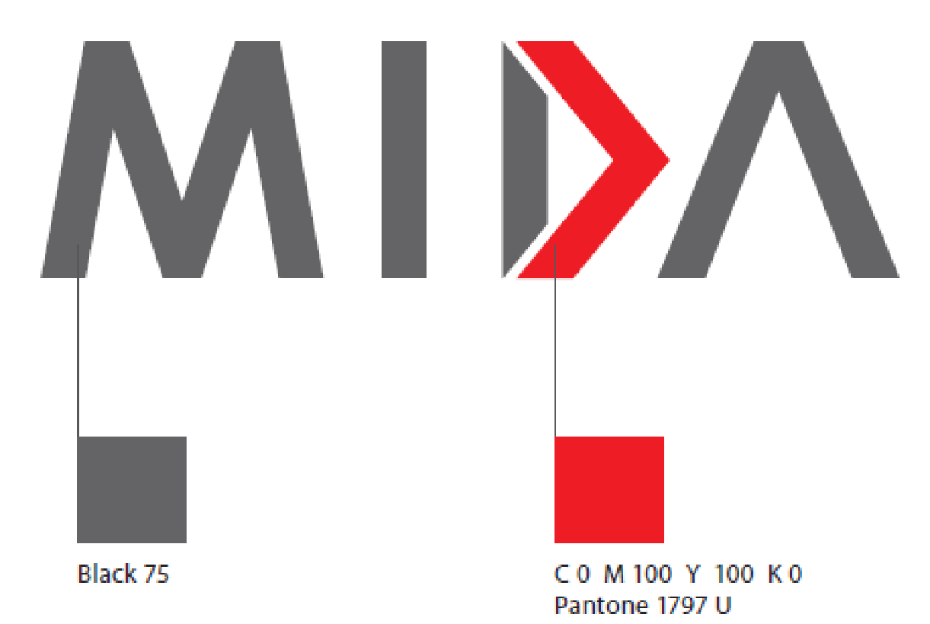 | 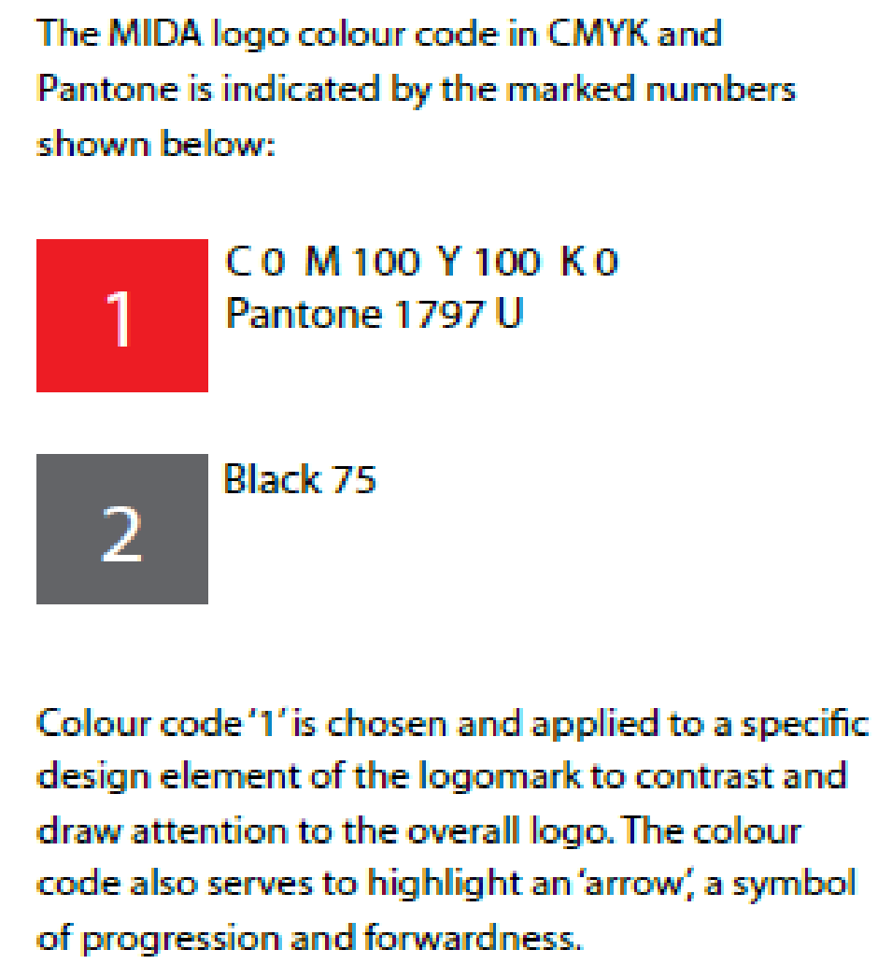

- Minimum Clear Space

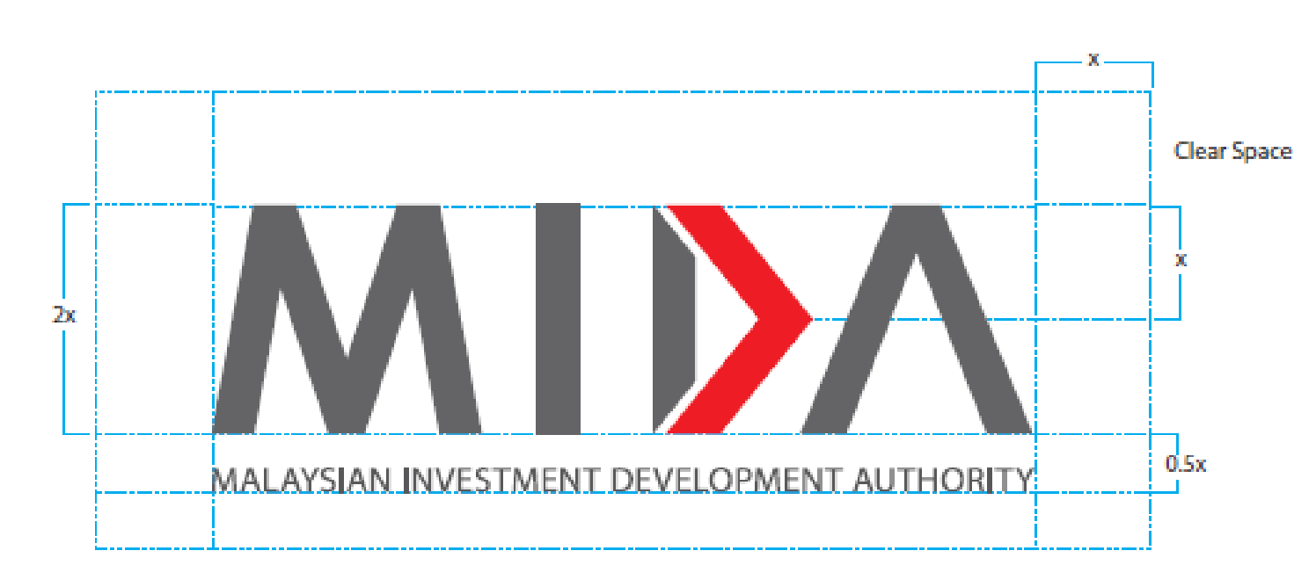 | 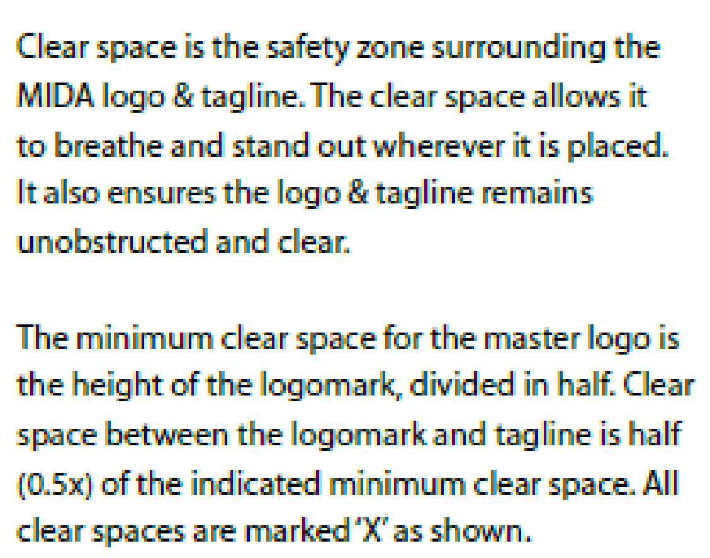

- Display Treatment

Besides the main display treatment, the tagline can also be used in alternative variations to suit different applications such as primary vertical and horizontal tagline lockup variations as shown below.

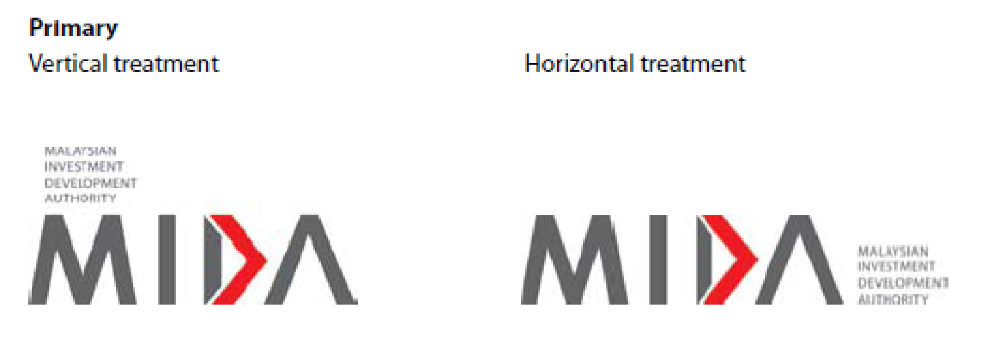
Tagline lockup variations, for both the vertical and horizontal treatments should not be any smaller than the indicated minimum sizes – 2cm vertically and 1cm horizontally.

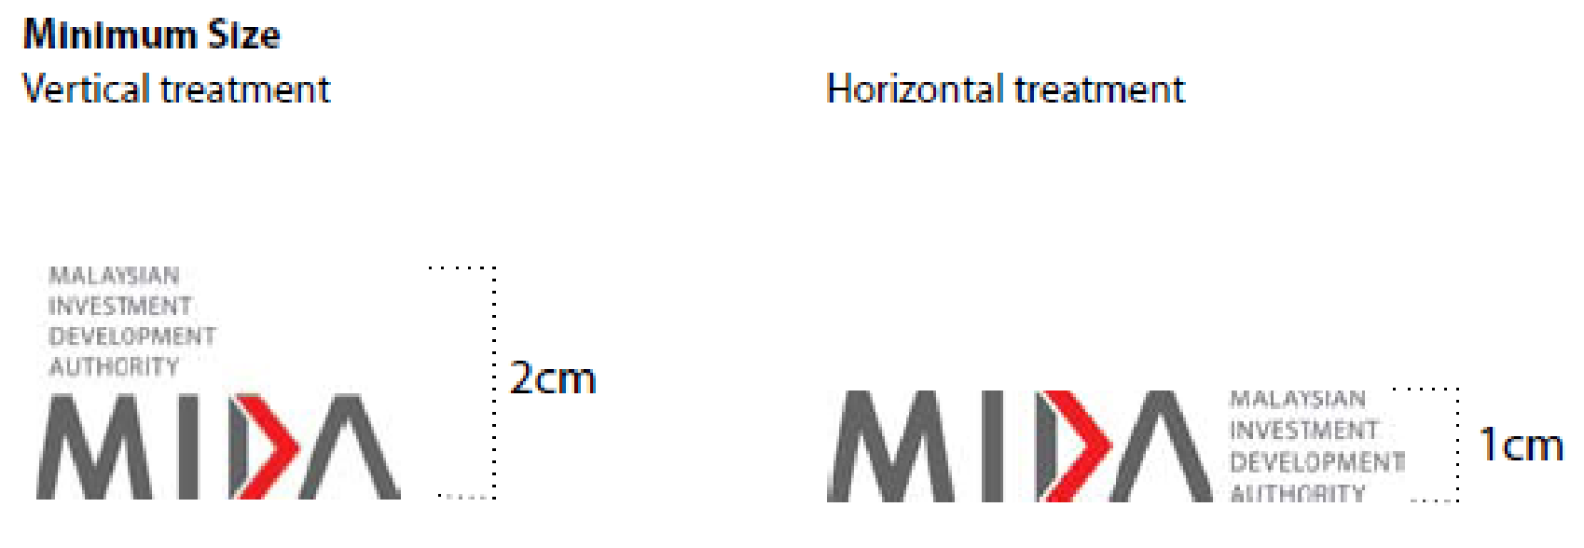

- Corporate Colours - Primary
There are three primary colours that make up the MIDA corporate colours. CMYK and Pantone colour codes are provided below.

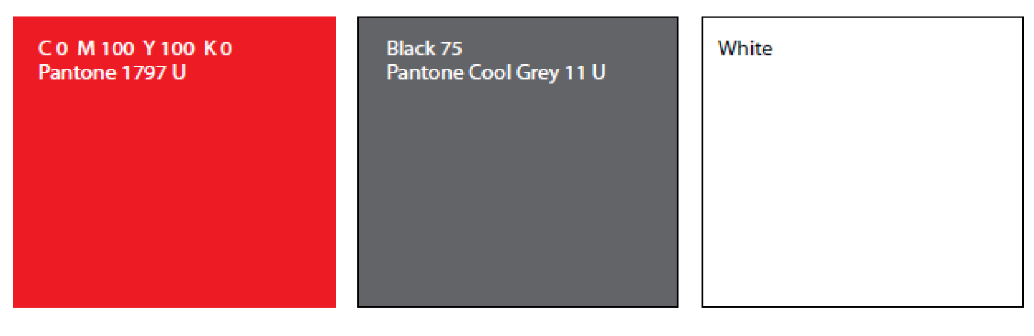

- Acceptable Usage
The logo can be applied to coloured backgrounds. Acceptable background colours are shown below. The selected colours ensure that the logo and tagline remain clear and readable when applied on different backgrounds.

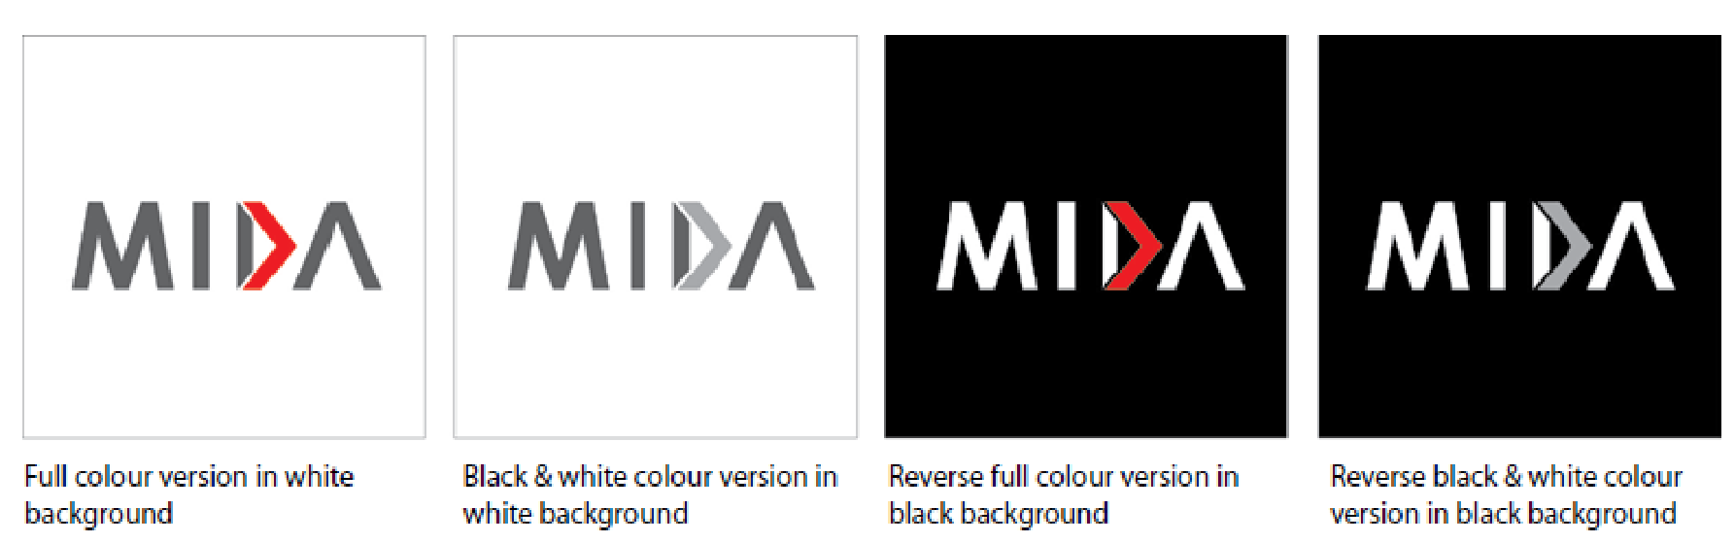

- Unacceptable Usage
Do keep in mind that logo must always remain strong and legible. Below are examples of unacceptable background colours that do not work against the logo.

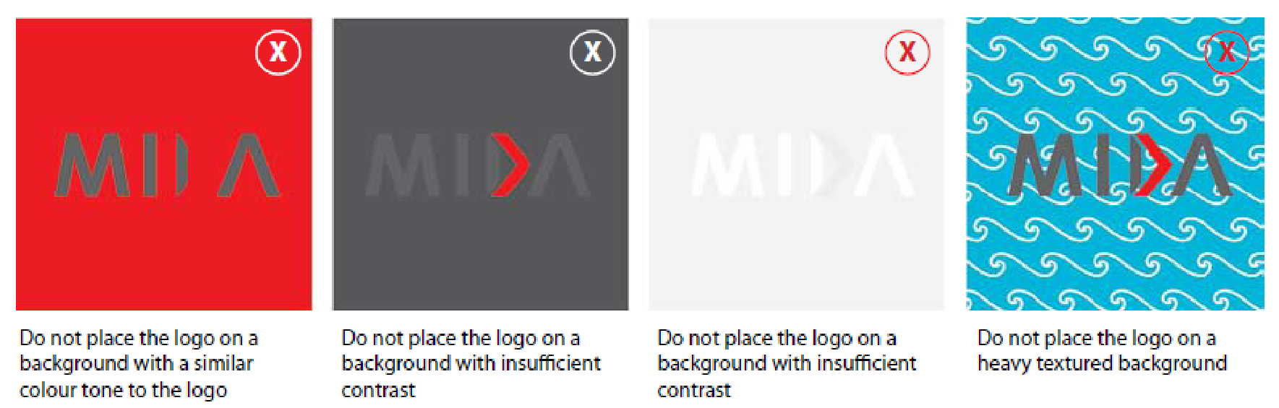

- Secondary Colours
There are four secondary colours that make-up the MIDA corporate colours.
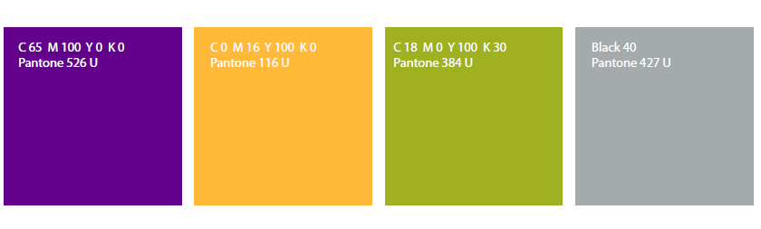

- Colour Swatch for Digital Creative

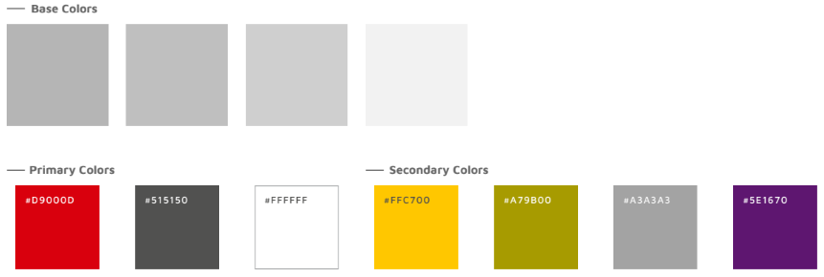

MIDA Logo Usage Disclaimer

The MIDA logo is an exclusive trademark owned by the Malaysian Investment Development Authority (MIDA), protected by copyright and trademark laws.
Unauthorised use, alteration, or distortion of the logo is strictly prohibited. Use is permitted only with express written authorisation from MIDA, and any such use does not imply endorsement or affiliation unless explicitly stated in writing.

a) Permitted Use
You are permitted to use the MIDA logo in the following circumstances:
- Strategic Partnership or Collaboration: If you are a strategic partner or collaborator with MIDA.
- Promotion of Malaysia as an Investment Destination: When using the MIDA logo to promote Malaysia as an investment destination.
- Non-misleading and Non-defamatory Usage: The MIDA logo may be used as long as it is not employed in a manner that is misleading or defamatory of MIDA.
- Monetary Implications: Any usage of the MIDA logo with monetary implications requires prior written permission from MIDA.
Any use of the MIDA logo that involves financial gain or monetary implications requires prior written
permission from MIDA. This includes, but is not limited to:
- Use on Products or Services for Sale: The use of the MIDA logo on products or services offered for sale.
- Inclusion in Marketing or Advertising Materials: The use of the MIDA logo in marketing or advertising materials that promote events, products, or services for sale.
- Endorsement Implication: The use of the MIDA logo in any way that suggests an endorsement of
an event, product, or service for sale.

b) Prohibited Use
You are prohibited from using the MIDA logo in the following circumstances:
- Non-Strategic Partnership or Collaboration: If you are not a MIDA strategic partner or collaborator.
- Self-Promotion without Permission: If you are using the MIDA logo to promote yourself or your organisation without prior written permission from MIDA.
- Misleading or Defamatory Usage: If you are using the MIDA logo in a way that is misleading or defamatory of MIDA.

c) Consequences of Unauthorised Use
If you use the MIDA logo without permission, you may be subject to legal action. This may include:
- A demand to cease and desist from using the MIDA logo.
- A claim for damages.
- Criminal prosecution.

d) How to Request Permission to Use the MIDA Logo
If you would like to request permission to use the MIDA logo, please contact MIDA at
investment@mida.gov.my

e) Frequently Asked Question
Please visit MIDA website at https://www.mida.gov.my/faq/ to learn more about MIDA Logo Usage.

Corporate Communications Division (CCD)
Malaysian Investment Development Authority (MIDA)
11 November 2023

