
Appendix I/2

BRAND GUIDELINES (as at 11 November 2023)
Malaysian Investment Development Authority (MIDA) logo is an important part of our organisation’s valuable intellectual property. Correct usage of MIDA’s logo is integral to developing and maintaining a consistent brand image and message about our organisation. The monogram and logotype that comprise our corporate logo have been carefully designed. Do not redraw or alter the artwork in any way. Any authorised usage of MIDA logos must comply with MIDA's requirements.

Any use of MIDA's logo must be (a) truthful, fair, not misleading, and (b) comply with MIDA's requirements, which may be modified at any time at MIDA's sole discretion. Always use the logo in the manner intended by MIDA. Do not alter them in any way. Do not make puns out of them or portray them negatively.

- Vision

Malaysia as the pre-eminent preferred investment destination.

- Mission

We build dynamic and sustainable investment ecosystem.

- The Master Logo


- Logo Rationale

 | 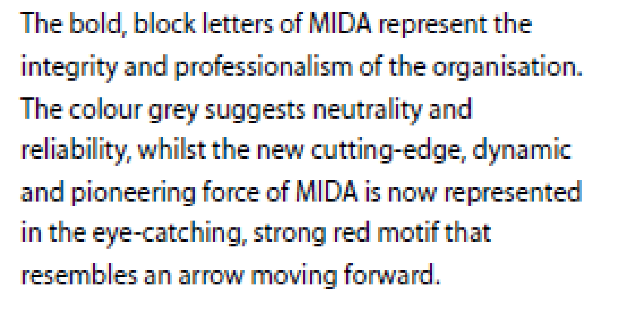
- Master Logo Elements
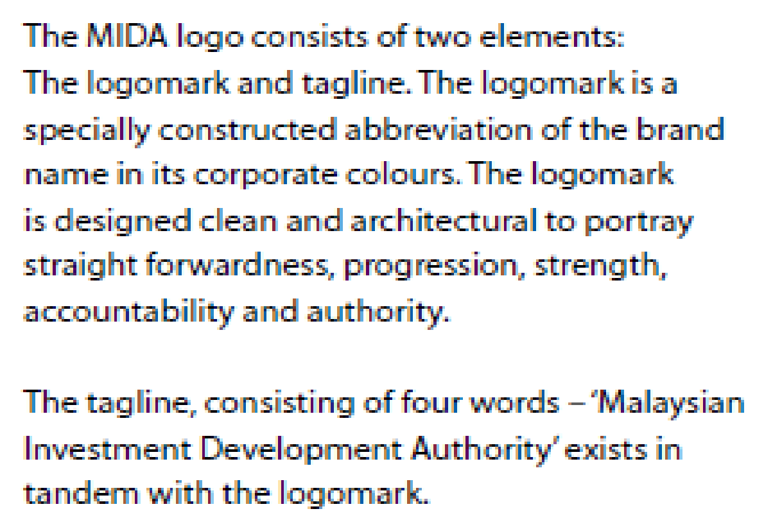

- Colour Code (Red: Pantone 1797U ; Grey: Pantone Cool Grey 11U)

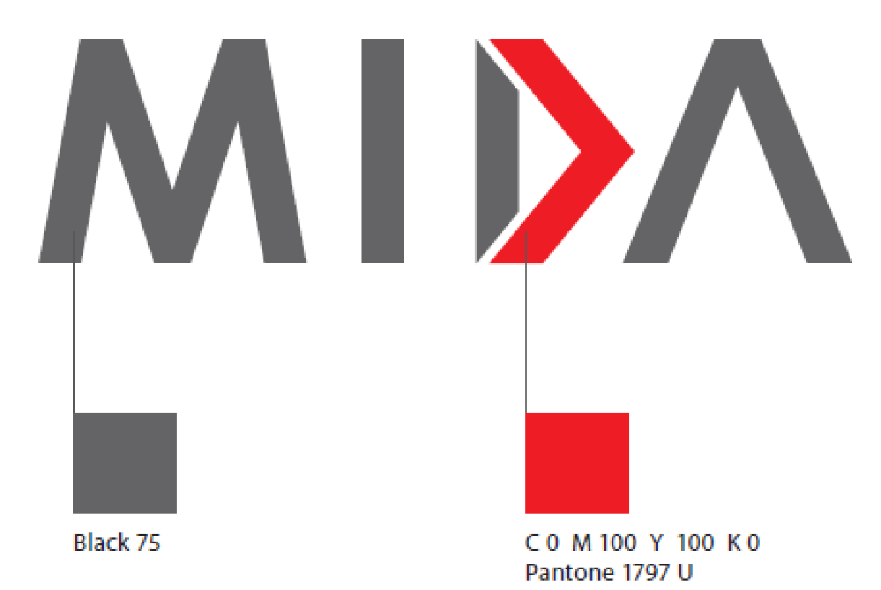 | 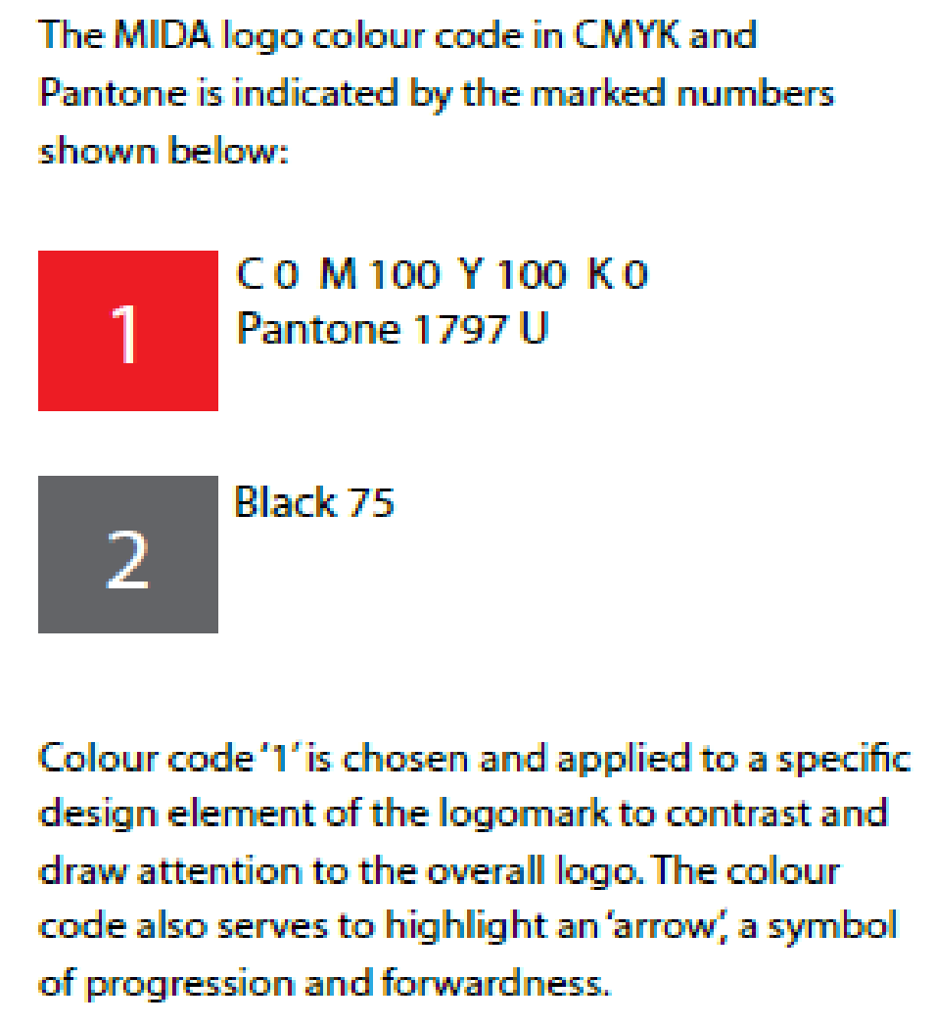

- Minimum Clear Space

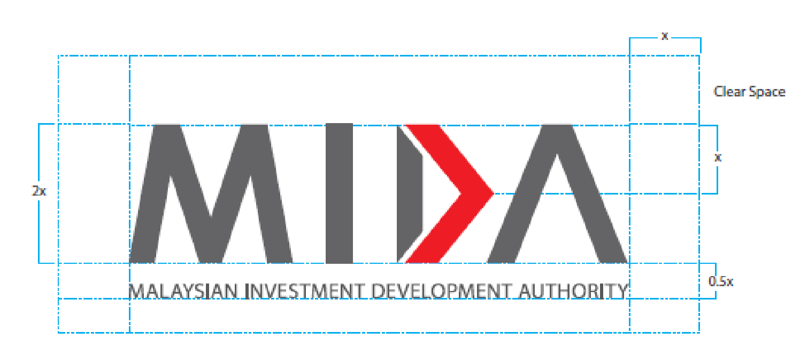 | 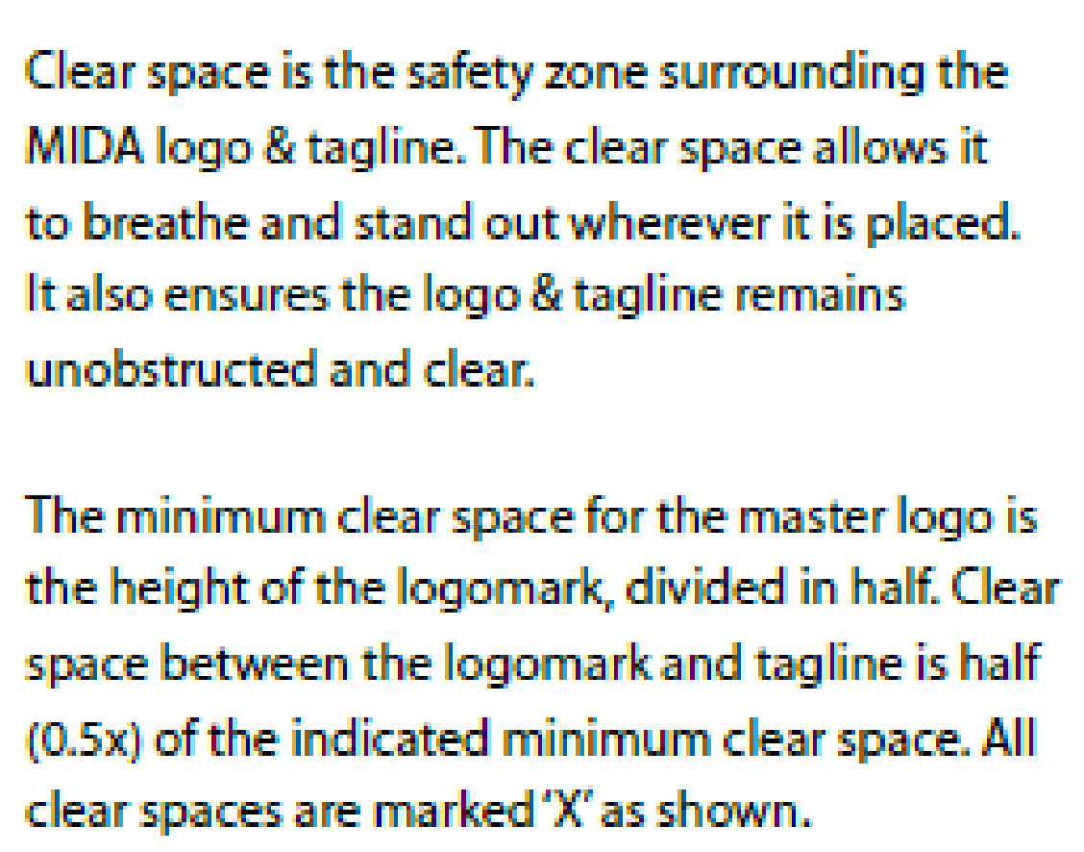

- Display Treatment

Besides the main display treatment, the tagline can also be used in alternative variations to suit different applications such as primary vertical and horizontal tagline lockup variations as shown below.

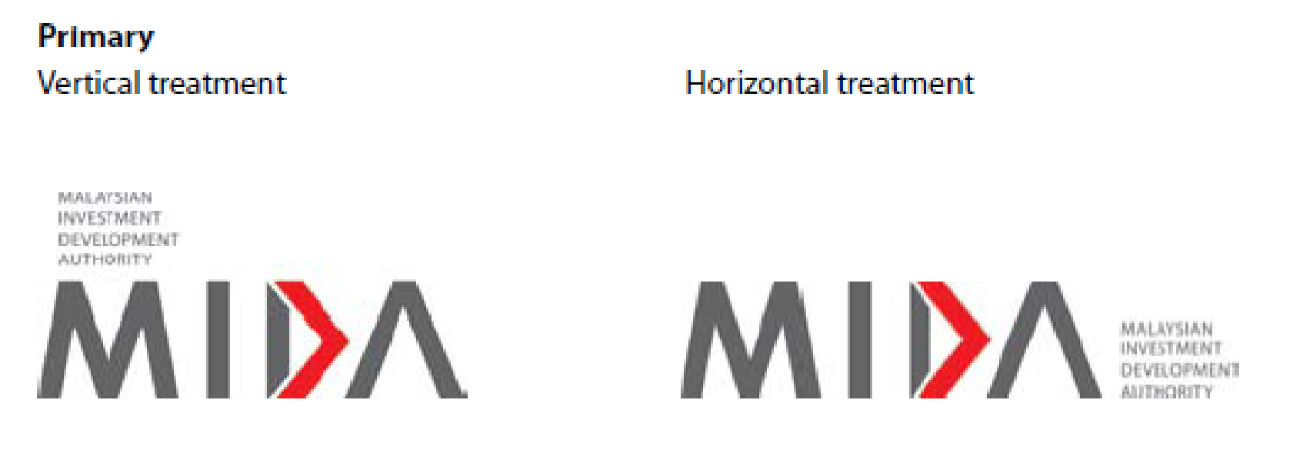
Tagline lockup variations, for both the vertical and horizontal treatments should not be any smaller than the indicated minimum sizes – 2cm vertically and 1cm horizontally.

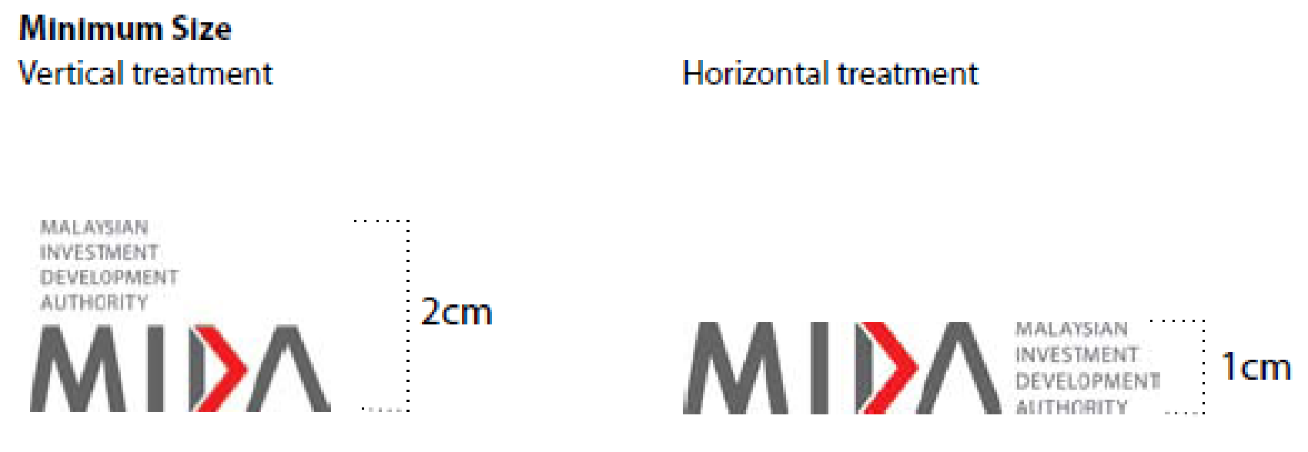

- Corporate Colours - Primary
There are three primary colours that make up the MIDA corporate colours. CMYK and Pantone colour codes are provided below.

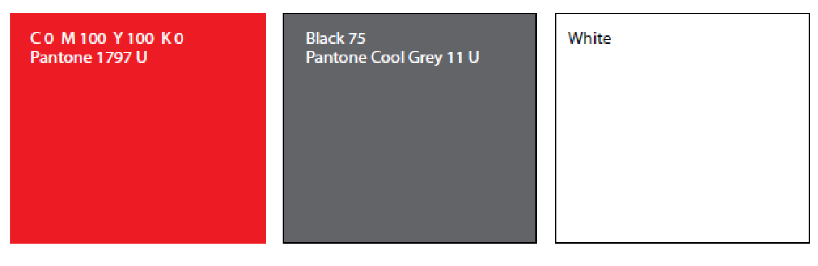

- Acceptable Usage
The logo can be applied to coloured backgrounds. Acceptable background colours are shown below. The selected colours ensure that the logo and tagline remain clear and readable when applied on different backgrounds.

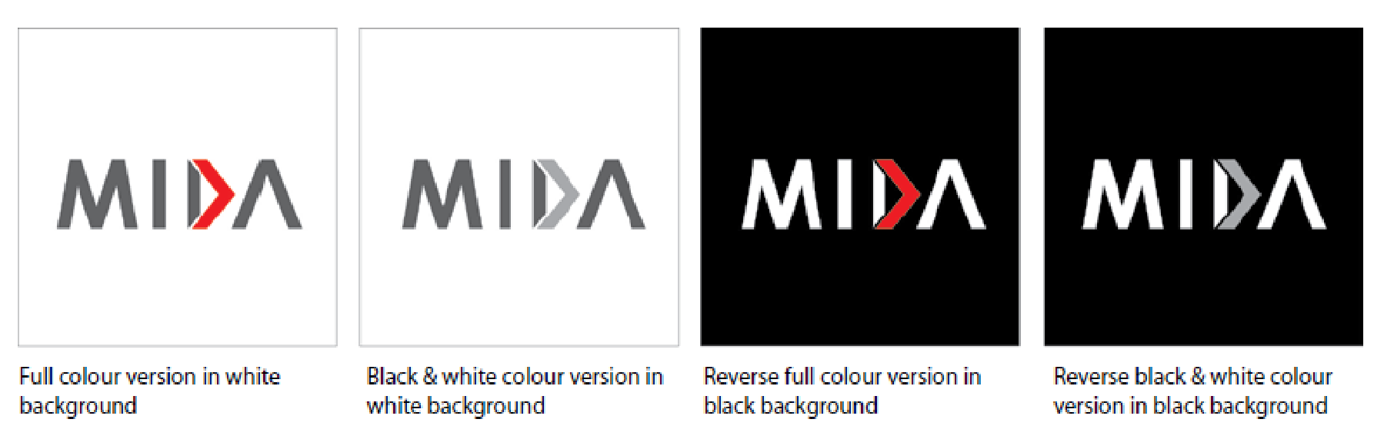

- Unacceptable Usage
Do keep in mind that logo must always remain strong and legible. Below are examples of unacceptable background colours that do not work against the logo.

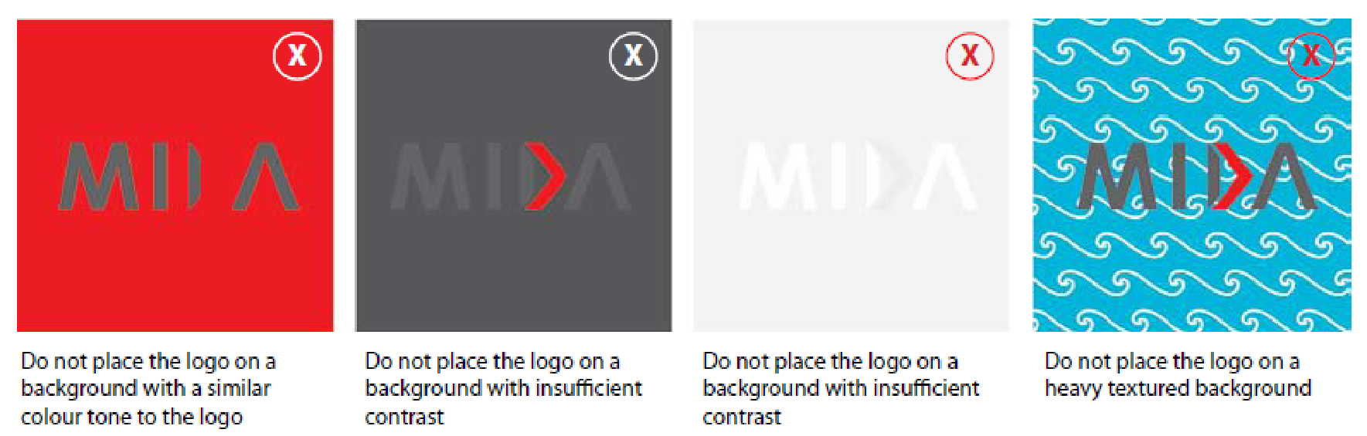

- Secondary Colours
There are four secondary colours that make-up the MIDA corporate colours.
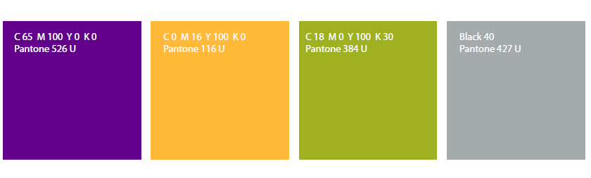

- Colour Swatch for Digital Creative

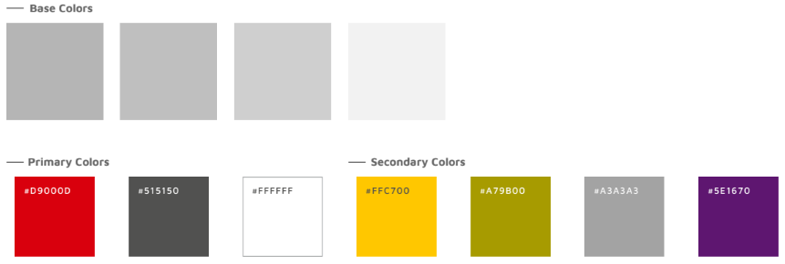

MIDA Logo Usage Disclaimer

The MIDA logo is an exclusive trademark owned by the Malaysian Investment Development Authority (MIDA), protected by copyright and trademark laws.
Unauthorised use, alteration, or distortion of the logo is strictly prohibited. Use is permitted only with express written authorisation from MIDA, and any such use does not imply endorsement or affiliation unless explicitly stated in writing.

a) Permitted Use
You are permitted to use the MIDA logo in the following circumstances:
- Strategic Partnership or Collaboration: If you are a strategic partner or collaborator with MIDA.
- Promotion of Malaysia as an Investment Destination: When using the MIDA logo to promote Malaysia as an investment destination.
- Non-misleading and Non-defamatory Usage: The MIDA logo may be used as long as it is not employed in a manner that is misleading or defamatory of MIDA.
- Monetary Implications: Any usage of the MIDA logo with monetary implications requires prior written permission from MIDA.
Any use of the MIDA logo that involves financial gain or monetary implications requires prior written
permission from MIDA. This includes, but is not limited to:
- Use on Products or Services for Sale: The use of the MIDA logo on products or services offered for sale.
- Inclusion in Marketing or Advertising Materials: The use of the MIDA logo in marketing or advertising materials that promote events, products, or services for sale.
- Endorsement Implication: The use of the MIDA logo in any way that suggests an endorsement of
an event, product, or service for sale.

b) Prohibited Use
You are prohibited from using the MIDA logo in the following circumstances:
- Non-Strategic Partnership or Collaboration: If you are not a MIDA strategic partner or collaborator.
- Self-Promotion without Permission: If you are using the MIDA logo to promote yourself or your organisation without prior written permission from MIDA.
- Misleading or Defamatory Usage: If you are using the MIDA logo in a way that is misleading or defamatory of MIDA.

c) Consequences of Unauthorised Use
If you use the MIDA logo without permission, you may be subject to legal action. This may include:
- A demand to cease and desist from using the MIDA logo.
- A claim for damages.
- Criminal prosecution.

d) How to Request Permission to Use the MIDA Logo
If you would like to request permission to use the MIDA logo, please contact MIDA at
investment@mida.gov.my

e) Frequently Asked Question
Please visit MIDA website at https://www.mida.gov.my/faq/ to learn more about MIDA Logo Usage.

Corporate Communications Division (CCD)
Malaysian Investment Development Authority (MIDA)
11 November 2023

