BAB 1

SURAT AKUAN PENYEBUTHARGA

LEMBAGA PEMBANGUNAN PELABURAN MALAYSIA
TINGKAT 14, MIDA SENTRAL, NO. 5
JALAN STESEN SENTRAL 5
KUALA LUMPUR SENTRAL
50470 KUALA LUMPUR.

SEBUTHARGA MIDA BIL. 19/2024

SEBUT HARGA PEROLEHAN MENJALANKAN KERJA-KERJA PENGUBAHSUAIAN RUANG PEJABAT INVEST MALAYSIA FACILITATION CENTRE (IMFC) DI TINGKAT 16 DAN 17, BANGUNAN MIDA SENTRAL

Kepada:

Penyebutharga-penyebutharga,
SURAT AKUAN PENYEBUTHARGA

Kepada:

Ketua Pegawai Eksekutif
Lembaga Pembangunan Pelaburan Malaysia
MIDA Sentral, No. 5
Jalan Stesen Sentral 5
Kuala Lumpur Sentral
50470 Kuala Lumpur.

Tuan,

SEBUTHARGA MIDA BIL: 19/2024

SEBUT HARGA PEROLEHAN MENJALANKAN KERJA-KERJA PENGUBAHSUAIAN RUANG PEJABAT INVEST MALAYSIA FACILITATION CENTRE (IMFC) DI TINGKAT 16 DAN 17, BANGUNAN MIDA SENTRAL

Di bawah dan tertakluk kepada Arahan Kepada Penyebutharga, saya yang menurunkan tandatangan di bawah ini adalah dengan ini mengambil bahagian sebutharga dan menawarkan untuk melaksanakan perkhidmatan di atas mengikut penentuan spesifikasi yang ditetapkan di dalam Dokumen Sebutharga.

2. Saya yang menurunkan tandatangan di bawah ini bersetuju menerima serta mematuhi dan terikat dengan semua Syarat-syarat Kontrak dan Spesifikasi Sebutharga ini dan bersetuju di atas harga yang ditawarkan RM……….............. sebagai asas perkiraan bagi pembayaran perkhidmatan yang telah dipesan oleh Lembaga Pembangunan Pelaburan Malaysia (MIDA).

3. Dengan ini juga telah difahami bahawa MIDA berhak menerima atau menolak sebarang sebutharga ini, sama ada harga yang ditawarkan rendah atau tinggi atau sama dengan sebutharga-sebutharga yang lain. Saya juga bersetuju untuk menerima kesemua atau sebahagian dari item-item yang ditawarkan dan sedia mengikut kehendak dan pertimbangan MIDA. Saya juga bersetuju bahawa harga sebutharga yang saya beri ini akan sahlaku (valid) dan tidak ditarik balik dalam tempoh sembilan puluh (90) hari dari tarikh tutup sebutharga dan tiada apa-apa syarat dikenakan selepas tarikh ditetapkan.

4. Selanjutnya saya bersetuju sekiranya sebutharga saya diterima, saya akan mengikat perjanjian kontrak serta memberi bon pelaksanaan dalam tempoh empat belas (14) hari dari tarikh terima surat tawaran dari MIDA, sekiranya diarahkan.

5. Saya juga mengesahkan, setelah menyemak sendiri iaitu semua dokumen yang digunakan untuk sebutharga ini adalah yang sebenar yang terdapat di dalam Dokumen Sebutharga.

Nama Penyebutharga | :
 |  |  |  | (Tandatangan Penyebutharga)
Alamat dan Cop Rasmi Syarikat | :
Tarikh | :
Nama Saksi | :
 |  |  |  | (Tandatangan Saksi)
Alamat | :

SURAT AKUAN PEMBIDA
SEBUT HARGA PEROLEHAN MENJALANKAN KERJA-KERJA PENGUBAHSUAIAN RUANG PEJABAT INVEST MALAYSIA FACILITATION CENTRE (IMFC) DI TINGKAT 16 DAN 17, BANGUNAN MIDA SENTRAL
(SEBUTHARGA MIDA NO. 19/2024)

Saya, ............................................... No. Kad Pengenalan ……………………...... yang mewakili ……………................................. nombor Pendaftaran ………………. dengan ini mengisytiharkan bahawa saya atau mana-mana individu yang mewakili syarikat ini:-

- tidak akan menawarkan, menjanjikan atau memberikan apa-apa suapan kepada mana-mana orang dalam mana-mana Kementerian/Agensi atau mana-mana orang lain, sebagai suapan untuk dipilih dalam mana-mana perolehan; dan

- tidak akan melakukan atau terlibat dengan tipuan bida dalam mana-mana perolehan.

Bersama ini dilampirkan Surat Perwakilan Kuasa bagi saya mewakili syarikat seperti tercatat di atas untuk membuat pengisytiharan ini.

2. Sekiranya saya, atau mana-mana individu yang mewakili syarikat ini didapati terlibat dalam pakatan tipuan bida dengan syarikat lain berkenaan perolehan di atas atau menawarkan, menjanjikan atau memberikan apa-apa suapan kepada mana-mana orang dalam MIDA atau mana-mana orang lain sebagai dorongan untuk dipilih dalam perolehan seperti di atas, maka saya sebagai wakil syarikat bersetuju tindakan-tindakan berikut boleh diambil:

2.1 Hilang kelayakan untuk dinilai dan dilantik bagi perolehan di atas; dan

2.2 Lain-lain tindakan undang-undang/tatatertib mengikut undang-undang/peraturan perolehan Kerajaan yang berkuat kuasa.

3. Saya sesungguhnya faham bahawa:

3.1 saya atau mana-mana orang yang berkaitan dengan syarikat boleh didakwa bagi kesalahan* di bawah Akta Suruhanjaya Pencegahan Rasuah Malaysia 2009 [Akta 694] dan Kanun Keseksaan [Akta 574] serta boleh dihukum di bawah undang-undang masing-masing atas kegagalan saya atau mana-mana orang yang mewakili syarikat ini untuk mematuhi perkara (i) dalam surat akuan ini; atau

3.2 tindakan boleh dikenakan ke atas syarikat di bawah Akta Persaingan 2010 [Akta 712] atas kegagalan saya atau mana-mana orang yang mewakili syarikat ini untuk mematuhi perkara (ii) dalam surat akuan ini. Sekiranya syarikat didapati melanggar peruntukan seksyen 4(2)(d) Akta 712, syarikat boleh didenda tidak melebihi sepuluh peratus (10%) daripada pusing ganti (turn over) sepanjang tempoh suatu pelanggaran itu berlaku.

4. Sekiranya terdapat mana-mana orang cuba memperolehi atau meminta apa-apa suapan daripada saya atau mana-mana orang yang berkaitan dengan syarikat ini sebagai dorongan untuk dipilih dalam perolehan seperti di atas, maka saya berjanji akan dengan segera melaporkan perbuatan tersebut kepada pejabat Suruhanjaya Pencegahan Rasuah Malaysia (SPRM) atau balai polis yang berhampiran. Saya sedar bahawa kegagalan saya berbuat demikian adalah merupakan suatu kesalahan di bawah seksyen 25 (1) Akta Suruhanjaya Pencegahan Rasuah Malaysia 2009 [Akta 694] dan boleh dihukum di bawah seksyen 25(2) akta yang sama, apabila disabitkan boleh didenda tidak melebihi RM100,000 atau penjara selama tempoh tidak melebihi sepuluh tahun atau kedua-duanya.

5. Saya sesungguhnya faham bahawa syarikat melakukan kesalahan jika seseorang yang bersekutu dengan syarikat** memberikan, menjanjikan atau menawarkan suapan untuk memperoleh atau mengekalkan perniagaan atau faedah dalam menjalankan perniagaan di bawah seksyen 17A Akta Suruhanjaya Pencegahan Rasuah Malaysia 2009 [Akta 694], apabila disabitkan kesalahan boleh didenda tidak kurang daripada sepuluh kali ganda jumlah atau nilai suapan, atau RM1 juta, atau dipenjarakan selama tempoh tidak melebihi dua puluh tahun atau kedua-duanya.

Yang benar,

Tandatangan : ..................................................................
Nama : ..................................................................
No. KP : ..................................................................
Tarikh : ..................................................................
Cap Syarikat : ..................................................................

Catatan:
- *termasuk kesalahan ditetapkan dalam Jadual (Perenggan 3 (a), takrif "kesalahan ditetapkan") Akta Suruhanjaya Pencegahan Rasuah Malaysia 2009 [Akta 694] yang boleh dihukum di bawah Kanun Keseksaan [Akta 574].
- **seseorang yang bersekutu dengan syarikat merujuk kepada seksyen 17A (6) Akta Suruhanjaya Pencegahan Rasuah Malaysia 2009 [Akta 694], iaitu seseorang itu bersekutu dengan organisasi komersial jika dia seorang pengarah, pekongsi atau pekerja organisasi komersial itu atau dia ialah orang yang melaksanakan perkhidmatan untuk atau bagi pihak organisasi komersial itu.
- Surat Akuan ini hendaklah dikemukakan bersama surat perwakilan kuasa.
- Takrifan perusahaan di bawah Akta 712 merangkumi syarikat yang terlibat dengan perolehan Kerajaan.

BAB 2
SPESIFIKASI TEKNIKAL

SEBUT HARGA PEROLEHAN MENJALANKAN KERJA-KERJA PENGUBAHSUAIAN RUANG PEJABAT INVEST MALAYSIA FACILITATION CENTRE (IMFC) DI TINGKAT 16 DAN 17, BANGUNAN MIDA SENTRAL

KETERANGAN AM (GENERAL)
The scope of works includes to design, to plan, to construct, to build, to renovate, to convert, to supply, to install, to relocate, to remove and to deliver the following:
BIL | PERKARA | SPESIFIKASI
1. | Level 16  To renovate/construct 3 units of new Deputy Director room
 |  | To renovate/construct 3 units of new Deputy Director room with standard requirements (approximately room size 200 – 250sqft) and follow existing design & material
 |  | To supply and install 3 units of Deputy Director workstation c/w medium height cabinet, 3 units executive mesh chair and 6 units executive medium back mesh chair (follow existing design and supplier)
 |  | To install new electrical wiring and LAN Cable for 3 units of Deputy Director workstation.
 |  | To dismantle and demolish existing small room to build Deputy Director room.
 |  | Dismantle existing wiring at the wall in the Deputy Director room.
 |  | M&E (sprinkler and air-condition diffuser - if required).
2. | Level 16  To supply and install 10 units new workstation for IMFC staff at the pool area level 16.
 |  | To install new electrical wiring and LAN cable work for 10 units workstation of IMFC staff.
 |  | To supply and install 10 units IMFC staff workstation c/w fitting pedestal 3 drawer, 10 units executive medium back mesh chair. (small/medium size workstation)
 |  | The design and material of the workstation should obtain approval from MIDA prior to supply and install.
3. | Level 16  To supply and install medium height cabinet for automation room
 |  | To supply sufficient numbers of cabinet follow existing design and material.
4. | Level 17  To construct 3 units new Deputy Director room and additional work for the renovation
 | Deputy Director Room
 |  | To dismantle existing workstation, electrical wiring and LAN cable for 5 units of supporting staff workstation at processing room, 6 units of supporting workstation at Immigration pool area, 1 unit PA workstation and make good.
 |  | To demolish existing gypsum wall at processing room, utility room and Director room and dismantle partially glass wall for new walkaway built up area.
 |  | To renovate/construct 3 units of new Deputy Director room. (approximately size 200 – 250sqft) and follow existing design & material.
 |  | To install 2 new electrical wiring and LAN cable work for 2 units of new Deputy Director workstation.
 |  | To lay and install 2 units new wiring for sufficient LED lighting and lighting switch for new Deputy Director room. To relocate existing switch at Immigration Director room.
 |  | Inclusive all related work and hidden work for M&E (lighting, sprinkler and air-condition diffuser and ducting - if required)
 |  | To relocate existing heavy safe box at the processing room to the existing vault room.
 | New walkaway for 2 units new Deputy Director room
 |  | To demolish existing gypsum wall and glass wall follow proposal AutoCAD drawing.
 |  | To construct new walkaway for the entrance of 2 new Deputy Director room.
 |  | Inclusive all related work and hidden work for M&E (lighting, sprinkler and air-condition diffuser and ducting - if required)
 | New Processing Room
 |  | To dismantle existing electrical wiring and LAN cable for 6 units of supporting staff workstation at Immigration pool area for new processing room built up area.
 |  | To install new electrical wiring and LAN cable work for 4 units of supporting staff workstation.
 |  | M&E (sprinkler and air-condition- if required)
 | Miscellaneous Item
 |  | 1 unit projector (Panasonic PTLMW420) c/w conceal cabling, matrix switcher, hanging bracket & etc.
 |  | Sufficient carpet tile
 |  | Sufficient frosted sticker for glass wall
IMFC Signages
- The contractors are required to plan, design propose supply and install IMFC signages at main entrance signage at level 16 and 17. The specification and the requirements of the IMFC signages shall be approved by MIDA.
Air-condition works and air balancing works
- The contractors are required to measure, inspect, report, supply, design and deliver air-condition operation to ensure sufficient cooling distribution at the affected area. This is to ensure all the diffuser receive relevant speed for cooling distribution purpose. The contractors also required to supply and deliver additional diffuser scope of work for PA Executive Director Management Services.
6. | Other Scope of Works
 |  | Contractor are required to ensure all the dismantle scope of work c/w make good scope of work.
 |  | Contractor are also required to submit, to draw, to get approval, to revise and to provide new interior design (ID) and M&E layout (soft copy & hard copy) at the affected area.
 |  | Contractor shall be responsible to ensure all the scope of work and safety issue to be carried out during the construction period and to organize and cooperate with relocation contractors. Contractor also required to ensure the site area are in good condition and safe.

PETA LOKASI PENGUBAHSUAIAN RUANG PEJABAT INVEST MALAYSIA FACILITATION CENTRE (IMFC) DI TINGKAT 16, BANGUNAN MIDA SENTRAL
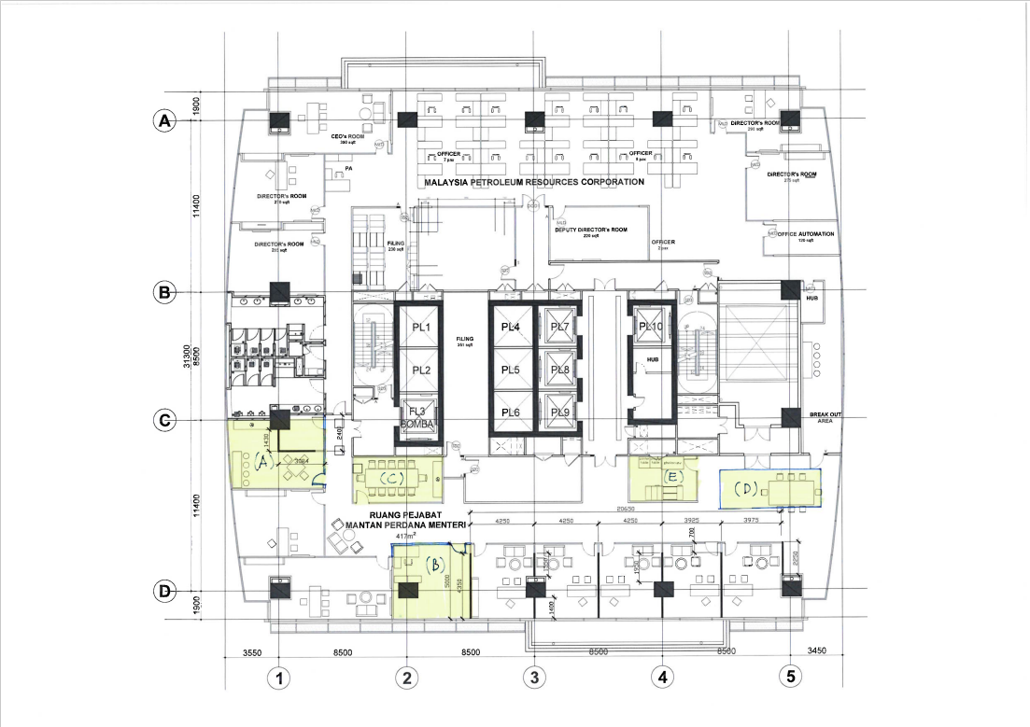
PETA LOKASI PENGUBAHSUAIAN RUANG PEJABAT INVEST MALAYSIA FACILITATION CENTRE (IMFC) DI TINGKAT 17, BANGUNAN MIDA SENTRAL

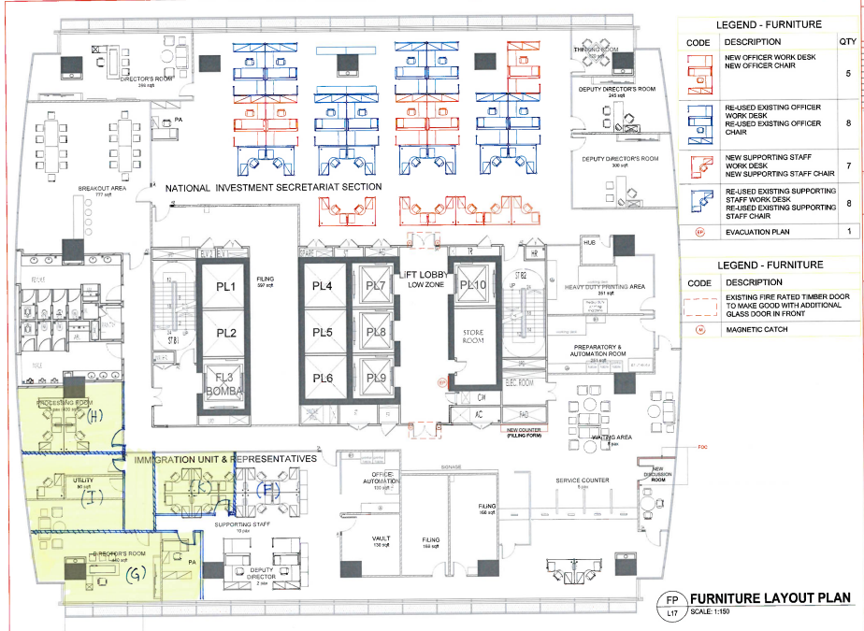

BAB 3
BORANG MAKLUMBALAS TEKNIKAL DAN JADUAL HARGA
JADUAL MAKLUMBALAS TEKNIKAL

KETERANGAN AM (GENERAL)
The scope of works includes to design, to plan, to construct, to build, to renovate, to convert, to supply, to install, to relocate, to remove and to deliver the following:
BIL | PERKARA | SPESIFIKASI | YA/  TIDAK | SPESIFIKASI YANG DITAWARKAN
1. | Level 16  To renovate/construct 3 units of new Deputy Director room
 |  | To renovate/construct 3 units of new Deputy Director room with standard requirements (approximately room size 200 – 250sqft) and follow existing design & material
 |  | To supply and install 3 units of Deputy Director workstation c/w medium height cabinet, 3 units executive mesh chair and 6 units executive medium back mesh chair (follow existing design and supplier)
 |  | To install new electrical wiring and LAN Cable for 3 units of Deputy Director workstation.
 |  | To dismantle and demolish existing small room to build Deputy Director room.
 |  | Dismantle existing wiring at the wall in the Deputy Director room.
 |  | M&E (sprinkler and air-condition diffuser - if required).
2. | Level 16  To supply and install 10 units new workstation for IMFC staff at the pool area level 16.
 |  | To install new electrical wiring and LAN cable work for 10 units workstation of IMFC staff.
 |  | To supply and install 10 units IMFC staff workstation c/w fitting pedestal 3 drawer, 10 units executive medium back mesh chair. (small/medium size workstation)
 |  | The design and material of the workstation should obtain approval from MIDA prior to supply and install
3. | Level 16  To supply and install medium height cabinet for automation room
 |  | To supply sufficient numbers of cabinet follow existing design and material.
4. | Level 17  To construct 3 units new Deputy Director room and additional work for the renovation
 | Deputy Director Room
 |  | To dismantle existing workstation, electrical wiring and LAN cable for 5 units of supporting staff workstation at processing room, 6 units of supporting workstation at Immigration pool area, 1 unit PA workstation and make good.
 |  | To demolish existing gypsum wall at processing room, utility room and Director room and dismantle partially glass wall for new walkaway built up area.
 |  | To renovate/construct 3 units of new Deputy Director room. (approximately size 200 – 250sqft) and follow existing design & material.
 |  | To install 2 new electrical wiring and LAN cable work for 2 units of new Deputy Director workstation.
 |  | To lay and install 2 units new wiring for sufficient LED lighting and lighting switch for new Deputy Director room. To relocate existing switch at Immigration Director room.
 |  | Inclusive all related work and hidden work for M&E (lighting, sprinkler and air-condition diffuser and ducting - if required)
 |  | To relocate existing heavy safe box at the processing room to the existing vault room.
 | New walkaway for 2 units new Deputy Director room
 |  | To demolish existing gypsum wall and glass wall follow proposal AutoCAD drawing.
 |  | To construct new walkaway for the entrance of 2 new Deputy Director room.
 |  | Inclusive all related work and hidden work for M&E (lighting, sprinkler and air-condition diffuser and ducting - if required)
 | New Processing Room
 |  | To dismantle existing electrical wiring and LAN cable for 6 units of supporting staff workstation at Immigration pool area for new processing room built up area.
 |  | To install new electrical wiring and LAN cable work for 4 units of supporting staff workstation.
 |  | M&E (sprinkler and air-condition- if required)
 | Miscellaneous Item
 |  | 1 unit projector (Panasonic PTLMW420) c/w conceal cabling, matrix switcher, hanging bracket & etc.
 |  | Sufficient carpet tile
 |  | Sufficient frosted sticker for glass wall
IMFC Signages
- The contractors are required to plan, design propose supply and install IMFC signages at main entrance signage at level 16 and 17. The specification and the requirements of the IMFC signages shall be approved by MIDA.
Air-condition works and air balancing works
- The contractors are required to measure, inspect, report, supply, design and deliver air-condition operation to ensure sufficient cooling distribution at the affected area. This is to ensure all the diffuser receive relevant speed for cooling distribution purpose. The contractors also required to supply and deliver additional diffuser scope of work for PA Executive Director Management Services.

6. | Other Scope of Works
 |  | Contractor are required to ensure all the dismantle scope of work c/w make good scope of work.
 |  | Contractor are also required to submit, to draw, to get approval, to revise and to provide new interior design (ID) and M&E layout (soft copy & hard copy) at the affected area.
 |  | Contractor shall be responsible to ensure all the scope of work and safety issue to be carried out during the construction period and to organize and cooperate with relocation contractors. Contractor also required to ensure the site area are in good condition and safe.

BAB 3 (SAMBUNGAN)
JADUAL MAKLUMBALAS HARGA

SEBUT HARGA PEROLEHAN MENJALANKAN KERJA-KERJA PENGUBAHSUAIAN RUANG PEJABAT INVEST MALAYSIA FACILITATION CENTRE (IMFC) DI TINGKAT 16 DAN 17, BANGUNAN MIDA SENTRAL

NO. | SKOP KERJA  PENGUBAHSUAIAN DI TINGKAT 16 | KUANTITI  (UNIT/SET) | HARGA SEUNIT  (RM) | JUMLAH  (RM)
1. | To renovate/construct 1 Unit Deputy Director Room
 | To design, supply and install for the glass wall, gypsum board wall, door and the door frame of the Deputy Director room. New switch lighting and wiring. | L/S
 | Workstation c/w fitting drawer, divider and etc. | 1
 | Executive mesh chair (black) | 1
 | Executive medium back mesh chair (black) | 2
 | To install electrical wiring related to power supply | 1
 | To install electrical wiring for CAD 6 | 2
 | Medium height sliding cabinet | 1
 | Demolish existing room (Reuse existing door and door frame for Deputy Director room | L/S
2. | To renovate/construct 1 Unit Deputy Director Room
 | To design, supply and install for the glass wall, gypsum board wall, door and the door frame of the Deputy Director room. New switch lighting and wiring. | L/S
 | Workstation c/w fitting drawer, divider and etc. | 1
 | Executive mesh chair (black) | 1
 | Executive medium back mesh chair (black) | 2
 | To install electrical wiring related to power supply | 1
 | To install electrical wiring for CAD 6 | 2
 | Medium height sliding cabinet | 1
3. | To renovate/construct 1 Unit Deputy Director Room
 | To convert existing room to Deputy Director room | L/S
 | Workstation c/w fitting drawer, divider and etc. | 1
 | Executive mesh chair (black) | 1
 | Executive medium back mesh chair (black) | 2
 | To install electrical wiring related to power supply | 1
 | To install electrical wiring for CAD 6 | 2
 | Medium height sliding cabinet | 1
 | Dismantle existing fitting automation cabinet | L/S
 | New switch lighting and wiring | L/S
4. | To supply and install 10 units workstation c/w fitting 3-layer drawer, divider and etc. | 10
 | Executive medium back mesh chair (black) | 10
 | To install electrical wiring related to power supply | 10
 | To install electrical wiring for CAD 6 | 10
5. | To supply and install new fitting automation cabinet | L/S
 | SKOP KERJA  PENGUBAHSUAIAN DI TINGKAT 17 | KUANTITI  (UNIT/SET) | HARGA SEUNIT  (RM) | JUMLAH  (RM)
6. | Dismantle 10 units supporting workstation at immigration pool area c/w M&E (electrical wiring and Cable LAN) | L/S
7. | To renovate 1 Unit existing Director room to Deputy Director room
 | To demolish existing gypsum wall, to dismantle existing door, door frame and accessories, fitting wardrobe cabinet | L/S
 | To dismantle existing PA Workstation and take out existing power and LAN cable | L/S
 | To rebuild gypsum wall, glass wall. To install and reuse existing door, door frame and accessories; and fitting wardrobe cabinet, if possible (or build new) | L/S
 | To relocate existing lighting switch, wiring and etc. | L/S
 | To reinstall existing PA workstation beside new processing room | L/S
8. | To renovate/construct 1 Unit Deputy Director Room
 | Demolish existing processing room, utility room and dismantle 5 supporting workstations, take out existing power and LAN cable | L/S
 | Relocate existing heavy safe box in the processing room to existing vault room | 1
 | To design, supply and install for the glass wall, gypsum board wall, door and the door frame of the Deputy Director room. New switch lighting and wiring | L/S
 | Workstation c/w fitting drawer, divider and etc. | 1
 | Executive mesh chair (black) | 1
 | Executive medium back mesh chair (black) | 2
 | To install electrical wiring related to power supply | 1
 | To install electrical wiring for CAD 6 | 2
 | Medium height sliding cabinet | 1
9. | To renovate/construct 1 Unit Deputy Director Room
 | To design, supply and install for the glass wall, gypsum board wall, door and the door frame of the deputy director's room. New switch lighting and wiring | L/S
 | Workstation c/w fitting drawer, divider and etc. | 1
 | Executive mesh chair (black) | 1
 | Executive medium back mesh chair (black) | 2
 | To install electrical wiring related to power supply | 1
 | To install electrical wiring for CAD 6 | 2
 | Medium height sliding cabinet | 1
10. | To renovate walkaway for 2 units new Deputy Director room
 | To build gypsum board wall, carpet and etc. To separate the Immigration pool area with new Deputy Director room | L/S
11. | To renovate/construct 1 unit new Immigration processing room at workstation pool area
 | To design, supply and install 1 unit Immigration printing room. The room must be built by using gypsum wall and glass wall follow the existing design in MIDA Sentral | L/S
 | Install door and door frame c/w high end door closer and Abloy lock set | L/S
 | Reinstall 4 units workstation from existing immigration processing room c/w power and LAN cable | L/S
 | New switch lighting and wiring | L/S
12. | To reinstall 10 units supporting workstation c/w power and LAN cable at level 21 (Statistics Division) | 10
13. | Miscellaneous Item - IMFC Signage
 | 2 units small size plate signage at the main entrance of IMFC Office at level 16 and 17 | 2
 | Supply and install medium height IMFC indoor signage 3D EG box up with LED light at pool area level 16 | 1
 | Supply and install medium height IMFC indoor signage 3D EG box up at the main entrance level 17 | 1
14. | Miscellaneous Item - To supply and install projector (Panasonic PTLMW420) c/w conceal cabling, matrix switcher, hanging bracket | L/S
15. | Miscellaneous Item - Upgrading flush valve and cold water supply main piping system at riser level 16 and 17.
 | Main vertical pipe size 100mm PPR PN16 flush valve and cold water supply main piping system from level 16 bottom to level 17 top complete with flange, bolt and nut, all necessary fitting inclusive of testing and commissioning | L/S
 | Sub pipe toilet male and female level 16 and 17:  To demolish of existing wall tiles, to supply and install concealed pipe, to provide competency and skill worker, tools, accessories, consumables and necessary equipment to lay new internal concealed pipe size 15mm, 25mm, 32mm, 40mm, 50mm and 80mm PVC class 7 cold water supply dan flush valve piping system c/w new tiles, socket, elbow, stopcock, hacking, painting and ceiling works complete with testing and commissioning | L/S
16. | Miscellaneous Item – Carpet Tiles | L/S
17. | Miscellaneous Item – Frosted Sticker | L/S
18. | Contingency
 | All related work or hidden work (M&E) and additional work that arises while renovations are being completed. HVAC balance and diffuser relocation work. | L/S
 | JUMLAH KESELURUHAN (RM)
 | SST 8% (JIKA ADA)
 | JUMLAH KESELURUHAN

Saya bagi pihak syarikat ____________________________ mengesahkan bahawa tawaran di atas adalah benar.

Tandatangan :
Nama :
Jawatan :
Cop Rasmi Syarikat :

BAB 4

- PENGALAMAN SYARIKAT

Senarai perkhidmatan yang sama yang pernah dibekalkan dalam tempoh tiga tahun terakhir mengikut kronologi:-
No. | Butiran Kontrak | Nama Pelanggan  dan Alamat | Jumlah  Kontrak (RM) | Tarikh Siap

- PROJEK YANG SEDANG DILAKSANAKAN

Senarai perkhidmatan:-
No. | Butiran Kontrak | Nama Pelanggan & Alamat | Jumlah Kontrak (RM) | Tarikh Mula | Tarikh Tamat

BAB 5

BUTIR-BUTIR PENYEBUTHARGA & MAKLUMAT KEWANGAN SYARIKAT

Syarikat perlu mengisi dengan lengkap semua seksyen dalam borang ini. Sekiranya ruang tidak mencukupi, maklumat boleh dikemukakan dalam kertas berasingan.

- MAKLUMAT AM

 | Nama Syarikat |  |  | :
 | Alamat |  |  | :
 | No. Telefon |  |  | :
 | No. Faks |  |  | :
 | Emel |  |  | :
 | Tarikh Pendaftaran / Penubuhan |  |  | :
 | No. Daftar Syarikat / Perniagaan |  |  | :
 | Tempat Pendaftaran/ Penubuhan |  |  | :
 | Komposisi Pemegang Saham |  |  | :
 |  | No. | Nama Pemegang Saham |  |  | Jawatan | % Pegangan

  - Peratusan Penyertaan Bumiputera : ________ (%). (Sila kemukakan maklumat lanjut atau salinan sah pendaftaran sebagai Pembekal Bumiputera dengan Kementerian Kewangan).

  - Maklumat Pendaftaran Kementerian Kewangan

No. | No. Pendaftaran | No. bidang | Butiran / Keterangan | Tempoh Sah

Nota : Sila lampirkan salinan sijil pendaftaran.

  - Sijil Pematuhan Cukai [Tax Compliance Certificate (TCC)]: sila lampirkan salinan sijil

  - Struktur Modal Syarikat :

- Modal Dibenarkan | :
- Modal Berbayar | :

B. KEWANGAN

a. Ringkasan aset dan tanggungan berdasarkan akaun yang diaudit bagi tiga (3) tahun terakhir.

Tahun Kewangan: | 2021  (RM) | 2022  (RM) | 2023  (RM)
- Jumlah Aset
- Aset Semasa
- Jumlah Tanggungan
- Tanggungan Semasa
- Nilai Bersih
- Modal Kerja

Nota : Penyata Kewangan yang telah diaudit bagi tiga (3) tahun berakhir hendaklah disertakan

    - Bank-bank Utama:

No. | Nama Bank & Alamat | Jenis Akaun
1.
2.
3.

    - Kemudahan Kredit (Jenis dan jumlah kredit yang boleh disediakan oleh syarikat:)

No. | Jenis Kemudahan Kredit | Bank/Institusi Kewangan | Jumlah (RM)
1.
2.
3.

SENARAI SEMAKAN
SEBUTHARGA PEROLEHAN MENJALANKAN KERJA-KERJA PENGUBAHSUAIAN RUANG PEJABAT INVEST MALAYSIA FACILITATION CENTRE (IMFC) DI TINGKAT 16 DAN 17, BANGUNAN MIDA SENTRAL
SEBUTHARGA MIDA BIL: 19/2024
Sila tandakan ( √ ) bagi dokumen-dokumen yang dikemukakan kepada MIDA:
Bil. | Perkara / Dokumen | Semakan oleh Syarikat | Semakan oleh  MIDA
 | Surat Akuan Petender
 | Surat Akuan Pembida
 | Maklumat SSM (Salinan sijil disertakan)
 | Berdaftar dengan SSM dan tempoh pendaftaran masih berkuatkuasa
 | - No. Sijil Pendaftaran (sila nyatakan)
 | - Tempoh Sahlaku Sijil Pendaftaran (nyatakan)
Syarikat berdaftar dengan CIDB dalam gred, kategori dan pengkhusuan berikut (dan tempoh pendaftaran masih berkuatkuasa):
Kelayakan:
- Sijil CIDB Gred G2

- Kategori: CE
CE21 : Pembinaan Kejuruteraan Awam

Dan/Atau

- Kategori: E
E11 : Kerja Am Elektrik

 | - No. Sijil Perakuan Pendaftaran Kontraktor (nyatakan)
 | - Tempoh Sahlaku Sijil Pendaftaran (nyatakan)
 | - Salinan Sijil Pendaftaran disertakan
 | - Salinan Sijil Perolehan Kerja Kerajaan disertakan
Syarikat berdaftar dengan Kementerian Kewangan (MOF) dalam kod bidang berikut (dan tempoh pendaftaran masih berkuatkuasa):

  - 020101: Perabot, Perabot Makmal dan
Kelengkapan Berasaskan Kayu / Rotan /
Fabrik /Logam / Plastik
(Workstations)

dan

  - 020301: Perkakas Elektrik dan Aksesori

 | - No. Sijil Akuan Pendaftaran (nyatakan)
 | - Tempoh Sahlaku Sijil Pendaftaran (nyatakan)
 | - Salinan Sijil disertakan
 | - Sijil Akuan Pendaftaran Bumiputera (jika ada)
 | - Peratus Penyertaan Bumiputera (nyatakan, jika ada)
 | Maklumbalas Teknikal (Hardcopy & Softcopy)
 | - Surat litup (cover letter) syarikat/penyebutharga
 | - Pengalaman syarikat
 | Maklumbalas Harga (Hardcopy & Softcopy)
 | - Ringkasan Sebutharga dan Borang Jadual Harga
 | - Penyata Kewangan untuk 3 tahun terakhir
 | - Penyata Bank untuk 3 bulan terakhir
 | Syarikat mengemukakan Sijil Pematuhan Cukai (TCC)
 | Lain-lain dokumen - profil syarikat, katalog, contoh kerja-kerja yang seumpamanya.

PENGESAHAN OLEH SYARIKAT

Dengan ini saya mengesahkan bahawa saya telah membaca dan memahami semua syarat-syarat dan terma yang dinyatakan di dalam dokumen sebut harga. Semua maklumat yang dikemukakan adalah benar.

Tandatangan | : | .....................................................................................
Nama | : | .....................................................................................
Jawatan | : | .....................................................................................
Tarikh | : | .....................................................................................

PENGESAHAN OLEH MIDA

Jawatankuasa Pembuka Sebut Harga mengesahkan penerimaan dokumen bertanda kecuali bagi perkara bil. .......................................... (jika ada) :-

Tandatangan | : | .....................................................................................
Nama | : | .....................................................................................
Jawatan | : | .....................................................................................
Tarikh | : | .....................................................................................

