BAB 1

SURAT AKUAN PENYEBUTHARGA

LEMBAGA PEMBANGUNAN PELABURAN MALAYSIA
TINGKAT 14, MIDA SENTRAL, NO. 5
JALAN STESEN SENTRAL 5
KUALA LUMPUR SENTRAL
50470 KUALA LUMPUR.

SEBUTHARGA MIDA BIL. 53/2021
SEBUTHARGA BAGI PERKHIDMATAN TO DEVELOP AND ENHANCE THE INVESTMALAYSIA SYSTEM FOR “PENGECUALIAN DUTI IMPORT BAHAN BESI DAN KELULI DALAM MENGHASILKAN KELUARAN SIAP UNTUK PASARAN EKSPORT, GUDANG PENGILANGAN BERLESEN (LMW) DAN ZON BEBAS (FZ).”

Kepada:

Penyebutharga-penyebutharga,

Borang ini hendaklah dikembalikan bersama-sama dengan JADUAL HARGA di dalam SAMPUL SURAT BERLAKRI

SURAT AKUAN PENYEBUTHARGA

Kepada:

Ketua Pegawai Eksekutif
Lembaga Pembangunan Pelaburan Malaysia
MIDA Sentral, No. 5
Jalan Stesen Sentral 5
Kuala Lumpur Sentral
50470 Kuala Lumpur.

Tuan,

SEBUTHARGA MIDA BIL: 53/2021

SEBUTHARGA BAGI PERKHIDMATAN TO DEVELOP AND ENHANCE THE INVESTMALAYSIA SYSTEM FOR “PENGECUALIAN DUTI IMPORT BAHAN BESI DAN KELULI DALAM MENGHASILKAN KELUARAN SIAP UNTUK PASARAN EKSPORT, GUDANG PENGILANGAN BERLESEN (LMW) DAN ZON BEBAS (FZ).”

Di bawah dan tertakluk kepada Arahan Kepada Penyebutharga, saya yang menurunkan tandatangan di bawah ini adalah dengan ini mengambil bahagian sebutharga dan menawarkan untuk melaksanakan perkhidmatan di atas mengikut penentuan spesifikasi yang ditetapkan di dalam Dokumen Sebutharga.

2. Saya yang menurunkan tandatangan di bawah ini bersetuju menerima serta mematuhi dan terikat dengan semua Syarat-syarat Kontrak dan Spesifikasi Sebutharga ini dan bersetuju di atas harga yang ditawarkan RM……….............. sebagai asas perkiraan bagi pembayaran perkhidmatan yang telah dipesan oleh Lembaga Pembangunan Pelaburan Malaysia.

3. Dengan ini juga telah difahami bahawa MIDA berhak menerima atau menolak sebarang sebutharga ini, sama ada harga yang ditawarkan rendah atau tinggi atau sama dengan sebutharga-sebutharga yang lain. Saya juga bersetuju untuk menerima kesemua atau sebahagian dari item-item yang ditawarkan dan sedia mengikut kehendak dan pertimbangan MIDA. Saya juga bersetuju bahawa harga sebutharga yang saya beri ini akan sahlaku (valid) dan tidak ditarik balik dalam tempoh sembilan puluh (90) hari dari tarikh tutup sebutharga dan tiada apa-apa syarat dikenakan selepas tarikh ditetapkan.

4. Selanjutnya saya bersetuju sekiranya sebutharga saya diterima, saya akan mengikat perjanjian kontrak serta memberi bon pelaksanaan dalam tempoh empat belas (14) hari dari tarikh terima surat tawaran dari MIDA, sekiranya diarahkan.

5. Saya juga mengesahkan, setelah menyemak sendiri iaitu semua dokumen yang digunakan untuk sebutharga ini adalah yang sebenar yang terdapat di dalam Dokumen Sebutharga.

Nama Penyebutharga | :
 |  |  |  | (Tandatangan Penyebutharga)
Alamat dan Cop Rasmi Syarikat | :
Tarikh | :
Nama Saksi | :
 |  |  |  | (Tandatangan Saksi)
Alamat | :

SURAT AKUAN PEMBIDA

SEBUTHARGA BAGI PERKHIDMATAN TO DEVELOP AND ENHANCE THE INVESTMALAYSIA SYSTEM FOR “PENGECUALIAN DUTI IMPORT BAHAN BESI DAN KELULI DALAM MENGHASILKAN KELUARAN SIAP UNTUK PASARAN EKSPORT, GUDANG PENGILANGAN BERLESEN (LMW) DAN ZON BEBAS (FZ).”

(SEBUTHARGA MIDA NO. 53/2021)

Saya, ………...………............................................ nombor K.P. …………….................... yang mewakili syarikat ….……………………….…….……………………….................... nombor Pendaftaran syarikat …….…………………................................ dengan ini mengisytiharkan bahawa saya atau mana-mana individu yang mewakili syarikat ini tidak akan menawar atau memberi rasuah kepada mana-mana individu dalam MIDA atau mana-mana individu lain, sebagai sogokan untuk dipilih dalam sebutharga seperti di atas. Bersama ini dilampirkan Surat Perwakilan Kuasa bagi saya mewakili syarikat seperti tercatat di atas untuk membuat pengisytiharan ini.

2. Sekiranya saya, atau mana-mana individu yang mewakili syarikat ini didapati cuba menawar atau memberi rasuah kepada mana-mana individu dalam MIDA atau mana-mana individu lain sebagai sogokan untuk dipilih dalam sebutharga seperti di atas, maka saya sebagai wakil syarikat bersetuju tindakan- tindakan berikut diambil:

2.1 Penarikan balik tawaran kontrak bagi sebutharga di atas; atau
2.2 Penamatan kontrak bagi sebutharga di atas; dan
2.3 Lain-lain tindakan tatatertib mengikut peraturan perolehan Kerajaan yang berkuat-kuasa.

3. Sekiranya terdapat mana-mana individu cuba meminta rasuah daripada saya atau mana-mana individu yang berkaitan dengan syarikat ini sebagai sogokan untuk dipilih dalam sebutharga seperti di atas, maka saya berjanji akan dengan segera melaporkan perbuatan tersebut kepada pejabat Suruhanjaya Pencegahan Rasuah Malaysia (SPRM) atau balai polis yang berhampiran.

Yang Benar,

……….................…………..
Nama :
No. KP :
Cop Syarikat :
BAB 2

TECHNICAL SPECIFICATION

- PURPOSE
This document outlines the functional and technical requirements to develop a solution for “Pengecualian Duti Import Bahan Besi dan Keluli Dalam menghasilkan Keluaran Siap Untuk Pasaran Eksport, Gudang Pengilangan Berlesen (LMW) dan Zon Bebas (FZ)” as part of enhancement of MIDA’s InvestMalaysia System.

- BACKGROUND

About MIDA
The Malaysian Investment Development Authority (MIDA) is the government's principal agency for the promotion of the manufacturing and services sectors in Malaysia. Incorporated as a statutory body under the Malaysian Industrial Development Authority (MIDA) Act, the establishment of MIDA in 1967 has spearheaded Malaysia’s industrial development.

MIDA assists companies which intend to invest in the manufacturing and services sectors, as well as facilitates the implementation of their projects. The wide range of services provided by MIDA includes providing information on the opportunities for investments, as well as facilitating companies which are looking for joint venture partners.

MIDA also evaluates the following applications for projects in the manufacturing and selected services sectors:
- Manufacturing licenses;
- Tax incentives;
- Expatriate posts;
- Duty exemptions on raw materials and components;
- Duty exemptions on machinery and equipment for agricultural sector and selected services sector; and
- Regional establishments.

MIDA Vision
“Malaysia as the pre-eminent preferred investment destination”.

MIDA Mission
“We build dynamic and sustainable investment ecosystems”.

MIDA HQ, Regional Offices and Overseas Centre
MIDA has established 12 regional offices and 20 overseas offices covering Asia Pacific, Europe, and US to assist investors in implementing their manufacturing projects and services.

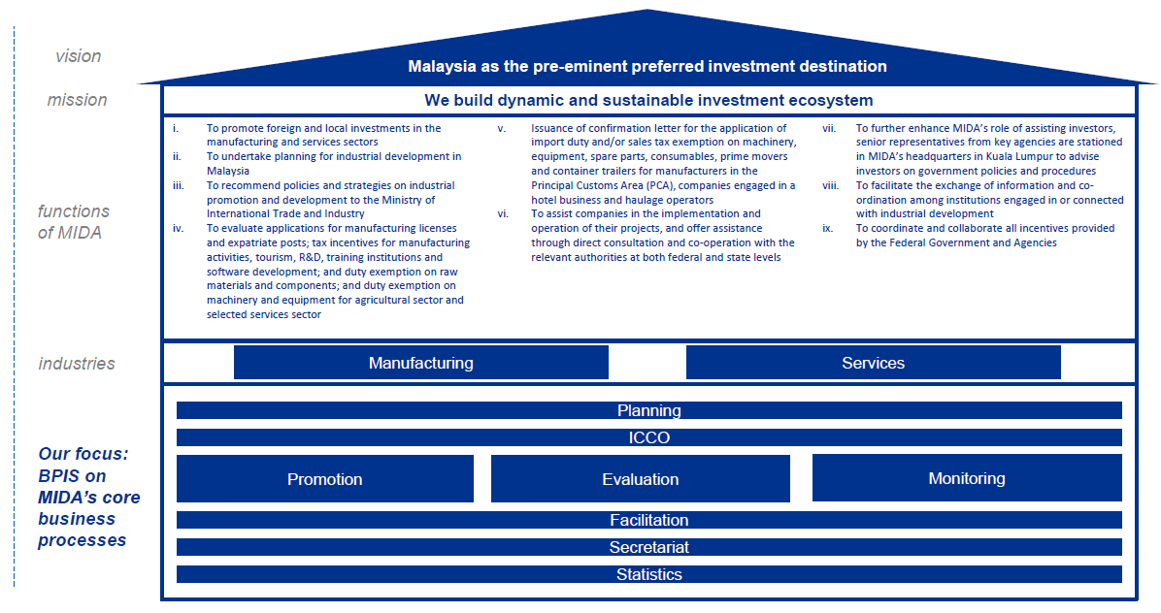
Figure 1: MIDA Organisation Context

The above diagram illustrates the organisational context of MIDA. The key functions of MIDA are established in order to drive MIDA towards reaching its vision and mission. MIDA focuses on two industries, mainly manufacturing and services. The eight (8) core business processes are as follows:
- Promotion
This function aims to promote local investment and Foreign Direct Investment (FDI) in the manufacturing and services sectors in Malaysia.

- Planning
This function contributes to the effectiveness in developing and reviewing investment policies, strategies and guidelines pertaining to investment matters of manufacturing and services industries in Malaysia.

- Evaluation
This function aims to ensure all applications received by MIDA are evaluated efficiently and effectively before proceeding to subsequent approval or rejection processes. In addition, this function oversees and manages the industries and services divisions’ development activities. This function liaises closely with the other functions mainly Monitoring and Facilitation.

- Monitoring
This function aims to enhance MIDA’s role as a service provider by assisting and ensuring that investors are well equipped and have obtained the necessary support required to successfully implement their projects.

- Secretariat
This function aims to coordinate any endorsements or approvals needed by MIDA management and various committee such as National Committee of Investment (NCI), and works closely with the seven (7) other core functions namely Planning, Promotion, Evaluation, ICCO, Monitoring, Facilitation and Statistics.

- Facilitation
This function aims to assist companies by providing relevant information and dealing with relevant agencies on project implementation. There are also promotion, evaluation and monitoring-related activities performed within this function.

- Statistics
This function aims to provide statistical data and information of investment figures for internal and external stakeholders.

- Incentive Coordination and Collaboration Office (ICCO)
This function is to improve coordination and effectiveness of total incentives offered by the Federal Government. ICCO acts as a central coordinating entity for incentives and liaises with MITI, MOF, EPU and other relevant agencies in performing their functions.
- INVESTMALAYSIA SYSTEM (https://investmalaysia.mida.gov.my)

3.1 InvestMalaysia System is an online application submission portal that serves as a single entry point for companies to submit their applications online and track its status. Modules available include the applications for manufacturing licence (e-ML), exemption letter from ML, incentive (e-Incentive), expatriate posts and Representative Office/Regional Office (RE/RO) status, Import Duty/Sales Tax Exemption (JPC) and MIDA Confirmation Letter [Surat Pengesahan MIDA (SPM)] as well as the Domestic Sales.

3.2 InvestMalaysia System is using OutSystems software (version 11.12.2) as a workflow engine for the application development and Microsoft MSSQL as its database.

The diagram below depicts the current application architecture within MIDA:

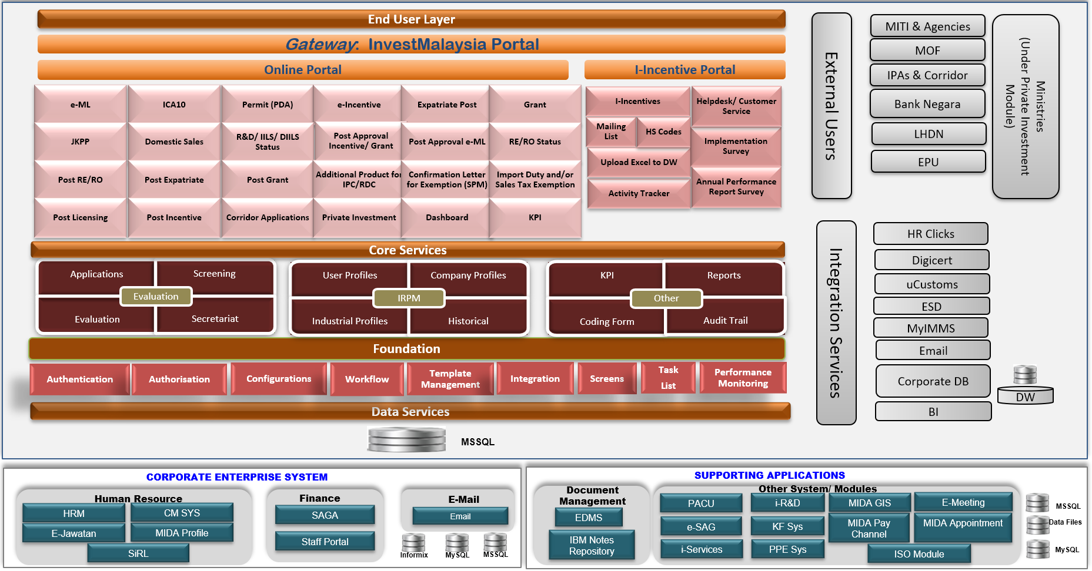

Figure 2: MIDA Current Application Architecture

3.3 The following InvestMalaysia system architecture depicts the current virtual hosting of servers in MIDA premise which is located in MIDA HQ, MIDA Sentral, No 5, Jalan Stesen Sentral 5, Kuala Lumpur Sentral, 50470 Kuala Lumpur.
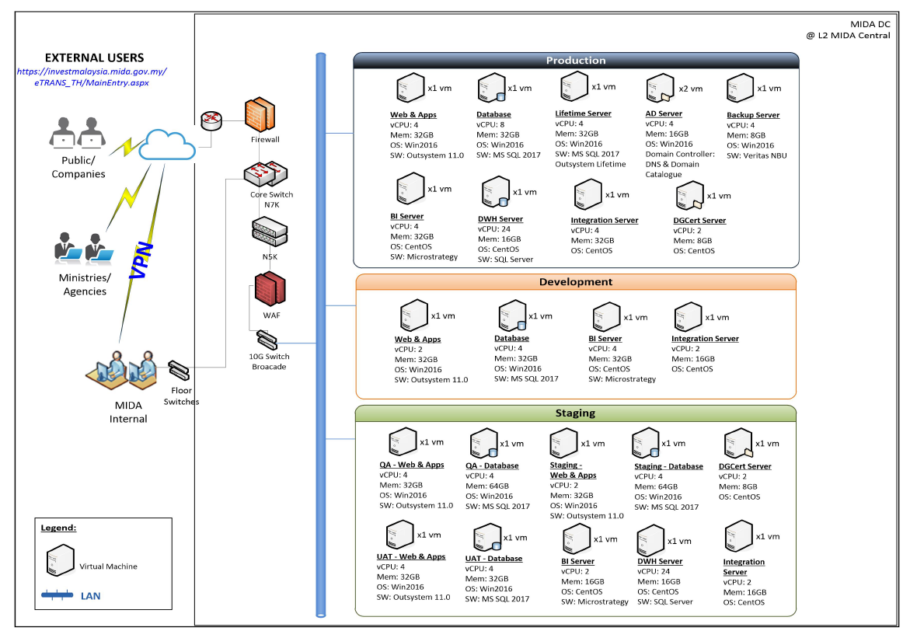
Figure 3: InvestMalaysia System Logical Architecture

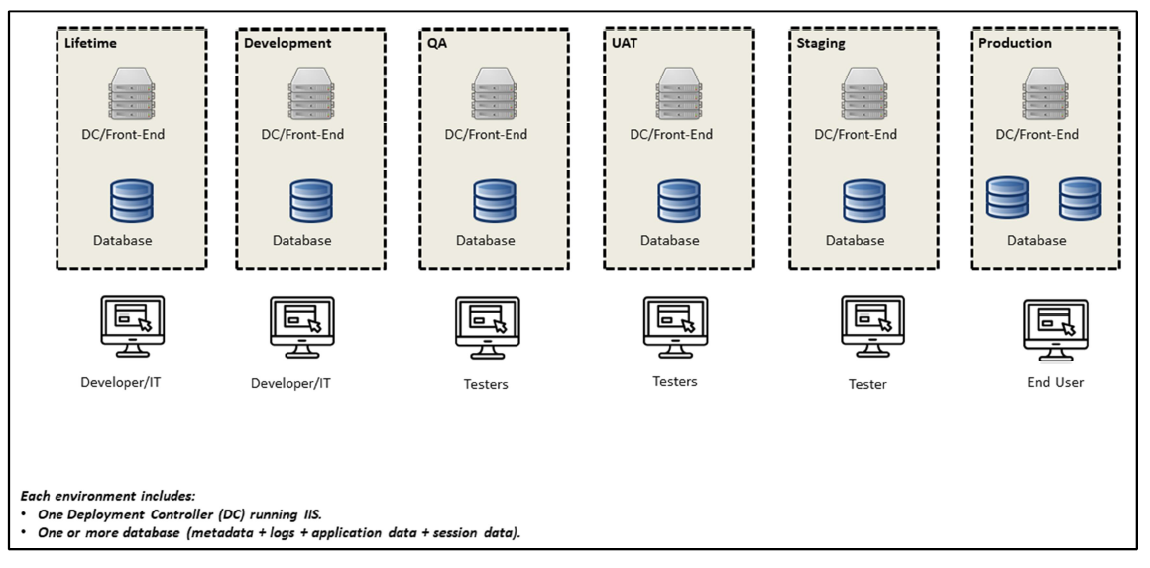
Figure 4: InvestMalaysia System Environments

3.4 The table below explains the InvestMalaysia Servers Specification which are segregated into five (5) environments – Production, Staging, UAT, QA and Development.

Server Type | Server Name | Server Specification | Remarks
Production
Web/App Server | MIDAPROD01 | vCPU: 4  vRAM: 32GB | - OutSystems Development Environment 11.0  - OutSystems Platform Servers
Database Server | MIDAPROD02 | vCPU: 8  vRAM: 32GB | - Microsoft ODBC Driver 13  - Microsoft SQL Server 2017 (64-bits)
Database Server | MIDAPROD04 | vCPU: 8  vRAM: 32GB | - Microsoft ODBC Driver 13  - Microsoft SQL Server 2017 (64-bits)
Lifetime Server | MIDALIFE01 | vCPU: 4  vRAM: 32GB | - Microsoft ODBC Driver 13  - Microsoft SQL Server 2017 (64-bits)  - OutSystems LifeTime  - OutSystems Platform Servers
Staging
Web/App Server | MIDASTG01 | vCPU: 4  vRAM: 32GB | - OutSystems Development Environment 11.0  - OutSystems Platform Servers
Database Server | MIDASTG02 | vCPU: 8  vRAM: 32GB | - Microsoft ODBC Driver 13  - Microsoft SQL Server 2017 (64-bits)
UAT
Web/App Server | MIDAUAT01 | vCPU: 4  vRAM: 32GB | - OutSystems Development Environment 11.0  - OutSystems Platform Servers
Database Server | MIDAUAT02 | vCPU: 4  vRAM: 132GB | - Microsoft ODBC Driver 13  - Microsoft SQL Server 2017 (64-bits)
QA
Web/App Server | MIDAQA01 | vCPU: 2  vRAM: 32GB | - OutSystems Development Environment 11.0  - OutSystems Platform Servers
Database Server | MIDAQA02 | vCPU: 4  vRAM: 128GB | - Microsoft ODBC Driver 13  - Microsoft SQL Server 2017 (64-bits)
Development
Web/App Server | MIDADEV01 | vCPU: 2  vRAM: 32GB | - OutSystems Development Environment 11.0  - OutSystems Platform Servers
Database Server | MIDADEV02 | vCPU: 4  vRAM: 32GB | - Microsoft ODBC Driver 13  - Microsoft SQL Server 2017 (64-bits)

Table 5: InvestMalaysia Servers Specifications

3.5 At present, MIDA is using Digital Certificates and Digital Signing Solution for its users to conduct online transaction. Digital certificate adopts the Public Key Infrastructure (PKI) framework for enabling the deployment of its three major functional uses namely Data Encryption, Digital Signature and Electronic Authentication. MIDA has appointed Pos Digicert Sdn. Bhd. to issue the Digital Certificates to its users. Pos Digicert Sdn. Bhd. is a Licensed Certification Authority under the Digital Signature Act 1997 (Act562).

3.6 MIDA uses Web Services to interface with MyCRS Digicert. There are integrations among all various applications within InvestMalaysia System as well as integration with Data Warehouse and Analytical tool.

- FUNCTIONAL REQUIREMENT

4.1 The tenderer is required to develop a solution for “Pengecualian Duti Import Bahan Besi dan Keluli Dalam menghasilkan Keluaran Siap Untuk Pasaran Eksport, Gudang Pengilangan Berlesen (LMW) dan Zon Bebas (FZ)” as part of enhancement of MIDA’s InvestMalaysia System with the following requirement:
- To Include Market information column in “Lampiran Bahan Mentah Table”, “Ditolak”, “Lampiran Tidak Dipertimbangkan”, and “Lampiran Pelanggan” for Working Evaluation Report, and Evaluation Report.
- To Include Market information column in “Lampiran Ditolak”, “Lampiran Tidak Dipertimbangkan” and “Lampiran Pelanggan” for Working Decision Letter, and Decision Letter.
- To include Market information column in Raw Materials and Components section

4.2 The Tenderer is required to study and design the complete process flow enhancement of InvestMalaysia System to cater for the development for “Pengecualian Duti Import Bahan Besi dan Keluli Dalam menghasilkan Keluaran Siap Untuk Pasaran Eksport, Gudang Pengilangan Berlesen (LMW) dan Zon Bebas (FZ)” during the User Requirement Study (URS), which must be agreed by MIDA.

4.3 Requirement for Working Evaluation Report and Evaluation Report:
  - To insert Market column in the “Bahan Mentah” Table in Working Evaluation Report.
  - To insert Market column in the “Bahan Mentah” Table in Evaluation Report (PDF).
  - To insert Market column in the “Lampiran Ditolak” in Evaluation Report (PDF).
  - To insert Market column in the “Lampiran Tidak Dipertimbangkan” in Evaluation Report (PDF).
  - To insert the Market column in the “Lampiran Pelanggan” in Evaluation Report (PDF).

4.4 Requirement for Working Decision Letter and Decision Letter:
- To insert Market column in the Bahan Mentah Table in Working Decision Letter.
- To insert Market column in the Lampiran Ditolak in Decision Letter (PDF).
- To insert Market column in the Lampiran Tidak Dipertimbangkan in Decision Letter (PDF).
- To insert the Market column in the Lampiran Pelanggan in Decision Letter (PDF).

4.5 Requirement for Application Form and Print Preview PDF:
- To insert Market column in the Raw Materials and Components section for Application Type Amendment (Application Form and Preview PDF).
- To insert Market column in the Raw Materials and Components section for Application Type Appeal (Application Form and Preview PDF).
- To insert Market column in the Raw Materials and Components section for Application Type Extension (Application Form and Preview PDF).
- To insert Market column in the Raw Materials and Components section for Application Type Additional Quantity (Application Form and Preview PDF).

4.6 Changes required on the system configurations:
    - To change the Decision Letter format in Template Management.
    - To change the Decision Letter format in Template Repository.

4.7 The enhancement/changes MUST be done via existing InvestMalaysia System which was developed using OutSystems low-code platform. Any related cost including the third party cost shall be borne by the Tenderer.

SCOPE OF WORK

The Tenderer is required to develop a solution for “Pengecualian Duti Import Bahan Besi dan Keluli Dalam menghasilkan Keluaran Siap Untuk Pasaran Eksport, Gudang Pengilangan Berlesen (LMW) dan Zon Bebas (FZ)” as part of enhancement to InvestMalaysia System based on the following requirement but not limited to:

  - The Tenderer shall study, design, enhance, test, deploy and support the current InvestMalaysia System to cater for changes to the affected screen as follow:
    - Application Form (Raw Materials and Components)
    - Print Preview PDF (Raw Materials and Components)
    - Working Evaluation Report (Form)
    - Evaluation Report (Print Preview PDF)
    - Working Decision Letter (Form)
    - Decision Letter (Print Preview PDF)

  - The Tenderer shall study, design, enhance, test, deploy and support the current InvestMalaysia System to cater for changes in template management as follow:
    - Template Repository (DL)
    - Template Management (Logic)

  - The Tenderer shall study, design, enhance, test, deploy and support the current InvestMalaysia System to cater for the affected database table(s).

  - The Tenderer shall study, design, enhance, test, deploy and support the current InvestMalaysia System to cater for changes to the affected processes as follow:
    - Generate Evaluation Report (PDF)
    - Generate Decision Letter (PDF)
    - Initialize and Access Working Evaluation Report (Form)
    - Initialize and Access Working Decision Letter (Form)
    - Initialize, Access and Submit Decision Letter format

- IMPLEMENTATION REQUIREMENT

  - Project Approach
The Tenderer must utilise a proven Project Management methodology to implement the project. Project Management methodology equivalent to PRINCE2, PMBOK or of a similar standard is preferred.

  - Project Team Structure
The project team structure proposed by the Tenderer shall be led by a certified Project Manager and consist of experienced Team Members in related areas.

The Tenderer must provide the CVs of the proposed team members.
.
6.3. Project Management Plan/Schedule
The Tenderer need to state the project management plan / schedule. The following should be included in the Proposal:
  - Project timeline in Gantt Chart
  - Project Organization Structure
  - Roles and Responsibilities of Team Members
  - Curriculum Vitae (CVs) and certifications of the Project Team.
  - Others (Please specify if any)

6.4 Equipment for Development and Testing
Equipment and hardware required for system development and testing will be provided by the Tenderer.

6.5 Project Monitoring and Reporting
The successful Tenderer shall prepare and submit status reports (based on an agreed format) that will enable the project committee to monitor the progress of the project. The reports shall be prepared and submitted throughout the duration of the project.

6.6 Training and Transfer of Technology (ToT)
The Tenderer must provide adequate training and Transfer of Technology (ToT) to MIDA system admin, technical and business users of InvestMalaysia.

6.7 Documentation and Source Code
The successful Tenderer shall provide complete documentation and user manual in English (hardcopy and softcopy) as well as deliver the source code of the developed system which shall belong to MIDA (as Government).

The Tenderer must ensure all the necessary technical and functional documentation are reviewed, approved and handed over to MIDA.

6.8 The Tenderer shall collaborate with the existing InvestMalaysia Maintenance Vendor on any issues related to InvestMalaysia System.

- DURATION

Tenderer is require to develop and implement the system for “Pengecualian Duti Import Bahan Besi dan Keluli Dalam menghasilkan Keluaran Siap Untuk Pasaran Eksport, Gudang Pengilangan Berlesen (LMW) dan Zon Bebas (FZ)”, within a period of six (6) months from the date of “Letter of Acceptance”.

- WARRANT AND SUPPORT

  - Warranty period of 12 months shall start upon the issuance date of Final Acceptance certificate.

  - The Tenderer must describe the scope of service (e.g. reporting process, response time, escalation procedure, status reporting, etc) and the roles and responsibilities of the parties involved during the warranty period.

  - The Tenderer must provide comprehensive support service to MIDA during the implementation and warranty period and respond to problems or issues pertaining to the module for “Pengecualian Duti Import Bahan Besi dan Keluli Dalam menghasilkan Keluaran Siap Untuk Pasaran Eksport, Gudang Pengilangan Berlesen (LMW) dan Zon Bebas (FZ)

  - The Tenderer must provide technical support assistance and issue/problem handling accordingly to the following SLA:

Severity 1 (Critical):
- Response Time within 30 minutes upon reported complaint/log
- Onsite Response Time: 2 working hours after Response Time
- Workaround Time: 8 working hours after Onsite Response Time

Severity 2 (Urgent):
  - Response Time within 1 hour upon reported complaint/log
  - Onsite Response Time: 4 working hours after Response Time
  - Workaround Time: 3 working days after Onsite Response Time

Severity 3 (Important):
  - Response Time within 1 hour upon reported complaint/log
  - Onsite Response Time: 8 working hours after Response Time
  - Workaround Time: 5 working days after Onsite Response Time

- FORMAT OF TECHNICAL PROPOSAL

9.1 The Tenderer must state the proposal according to the format provided below:
  - Table of Contents
  - Executive Summary
  - Short summary of company profile
  - It shall include a description of Vendor’s understanding of the project objectives, implementation approach and how these will be achieved.
  - Cover Letter
- Name of person(s) who will be the principal contact authorised to make commitments for the Vendor;
- Address, telephone number, fax number and e-mail address
  - Solution Specification Section
- Introduction
- Background Information
- Objectives
- Scope of Work
- Deliverables
- Appendices

  - The Tenderer must submit two (2) sets of hardcopy and one (1) softcopy in Microsoft Word

  - The Tenderer must respond and submit to the following Table of Response as belows:
No | Appendix | Title
 | Appendix 1 | Executive Summary
 | Appendix 2 | Technical and Implementation Requirements.
 | Appendix 3 | Summary of Proposed System Component
 | Appendix 4 | Project Implementation Plan
 | Appendix 5 | Proposed Project Team
 | Appendix 6 | Project Cost
 | Appendix 7 | Company Experiences and Background (Bab 5)

BAB 3
JADUAL MAKLUM BALAS TEKNIKAL
APPENDIX 1
Executive Summary

TECHNICAL AND IMPLEMENTATION REQUIREMENTS APPENDIX 2
All information must be clearly stated in the space provided. Failure to provide information will be considered non-compliance.
NO | ITEM | COMPLIANCE (YES/NO) | RESPONSE AND REFERENCE
The Tenderer is required to develop and enhance the InvestMalaysia System for “Pengecualian Duti Import Bahan Besi dan Keluli Dalam menghasilkan Keluaran Siap Untuk Pasaran Eksport, Gudang Pengilangan Berlesen (LMW) dan Zon Bebas (FZ)” as following requirement but not limited to:
 | FUNCTIONAL REQUIREMENT
The tenderer is required to enhance the InvestMalaysia System for JPC Export Market module to cater for the following requirement:
- To Include Market information column in “Lampiran Bahan Mentah Table”, “Ditolak”, “Lampiran Tidak Dipertimbangkan”, and “Lampiran Pelanggan” for Working Evaluation Report, and Evaluation Report.
- To Include Market information column in “Lampiran Ditolak”, “Lampiran Tidak Dipertimbangkan” and “Lampiran Pelanggan” for Working Decision Letter, and Decision Letter.
- To include Market information column in Raw Materials and Components section.
 | The Tenderer is required to study and design the complete process flow enhancement of Invest Malaysia application to cater for Change Request for JPC Export Market during the User Requirement Study (URS) and must be agreed by MIDA.
Requirement for Working Evaluation Report and Evaluation Report:
- To insert Market column in the Bahan Mentah Table in Working Evaluation Report.
- To insert Market column in the Bahan Mentah Table in Evaluation Report (PDF).
- To insert Market column in the Lampiran Ditolak in Evaluation Report (PDF).
- To insert Market column in the Lampiran Tidak Dipertimbangkan in Evaluation Report (PDF).
- To insert the Market column in the Lampiran Pelanggan in Evaluation Report (PDF).
Requirement for Working Decision Letter and Decision Letter:
- To insert Market column in the Bahan Mentah Table in Working Decision Letter.
- To insert Market column in the Lampiran Ditolak in Decision Letter (PDF).
- To insert Market column in the Lampiran Tidak Dipertimbangkan in Decision Letter (PDF).
- To insert the Market column in the Lampiran Pelanggan in Decision Letter (PDF).
Changes required on the system configurations:
- To change the Decision Letter format in Template Management.
- To change the Decision Letter format in Template Repository.
 | The enhancement/changes must be done via existing Invest Malaysia system which was developed using Outsystems low-code platform. Any related cost including the third party cost shall be borne by the Tenderer.
B. | SCOPE OF WORK
 | The Tenderer shall study, design, enhance, test, deploy and support the current Invest Malaysia application to cater for the affected screen changes as follow:
 | - Working Evaluation Report (Form)
 | - Working Decision Letter (Form)
 | - Evaluation Report (Print Preview PDF)
 | - Decision Letter (Print Preview PDF)
 | - Application Form (Raw Materials and Components)
 | - Print Preview PDF (Raw Materials and Components)
2. | The Tenderer shall study, design, enhance, test, deploy and support the current Invest Malaysia application to cater for changes in template management as follow:  - Template Repository (DL)  - Template Management (Logic)
3. | The Tenderer shall study, design, enhance, test, deploy and support the current Invest Malaysia application to cater for the affected database table(s).
4. | The Tenderer shall study, design, enhance, test, deploy and support the current Invest Malaysia application to cater for the affected processes changes as follow:
 | a. Generate Evaluation Report (PDF)
 | b. Generate Decision Letter (PDF)
 | c. Initialize and Access Working Evaluation Report (Form)
 | d. Initialize and Access Working Decision Letter (Form)
 | e. Initialize, Access and Submit Decision Letter format
C. | IMPLEMENTATION REQUIREMENT - PROJECT MANAGEMENT, TRAINING, DOCUMENTATION AND WARRANTY SUPPORT
 | The Tenderer must utilise a proven Project Management methodology to implement the project. Project Management methodology equivalent to PRINCE2, PMBOK or of a similar standard is preferred.
The project team structure proposed by the Tenderer shall be led by a certified Project Manager and consist of experienced Team Members in related areas.
Please specify.
The following should be included in the Proposal:
  - Project timeline in Gantt Chart
  - Project Organization Structure
  - Roles and Responsibilities of Team Members
  - Curriculum Vitae (CVs) and certifications of the Project Team.
  - Others (Pls specify if any)
 | Equipment and hardware required for system development and testing will be provided by the company.
 | The successful Tenderer shall prepare and submit status reports (based on an agreed format) that will enable the project committee to monitor the progress of the project. The reports shall be prepared and submitted throughout the duration of the project.
 | The Tenderer must provide adequate training and Transer of Technology (ToT) to MIDA system admin, technical and business users of InvestMalaysia.
 | The Tenderer must provide documentation and User Manual in English and in softcopy format.
 | The Tenderer must ensure all the necessary technical and functional documentation are reviewed, approved and handed over to MIDA.
 | The Tenderer must provide the necessary support of module until 12 months after the date of issuance of Final Acceptance certificate.
 | The Tenderer shall collaborate with the existing InvestMalaysia maintenance vendor on any issues related to InvestMalaysia System.
 | Tenderer must provide technical support assistance and issue/problem handling according to the proposed SLA.

APPENDIX 3
SUMMARY OF PROPOSED SYSTEM COMPONENT

APPENDIX 4
PROJECT IMPLEMENTATION PLAN

No. | Activities | Start Date | End Date
Note:
The Vendor shall submit in another relevant timeline format.

APPENDIX 5
PROPOSED PROJECT TEAM

Area of Expertise (Role) | Name | Age | Years of Experience | Citizenship (Malaysian /Non Malaysian) | Academic & Professional Qualification | Experience of Previous Similar Project
Project Leader
Application Leader
Team

Note:
The Curriculum Vitae (CV) of each proposed project team member is to be submitted as attachment.

BAB 4
JADUAL MAKLUM BALAS HARGA

APPENDIX 6

PROJECT COST
No. | Professional Services / Solution | Quantity | Unit Price (RM) | Amount (RM)
Sub Total (RM)
No. | Others (if any) | Quantity | Unit Price (RM) | Amount (RM)
Sub Total (RM)
Grand Total (RM)

BAB 5

COMPANY EXPERIENCE & BACKGROUND

1.0 The company shall provide information on company experiences and background of the company.

1.1 Employee

i. Full list on company management employee information.

NO | NAME | DESIGNATION | EXPERIENCE | QUALIFICATION
*Please specify in a separate attachment if there is not enough space provided
ii. Full list on company technical employee information.

NO | NAME | DESIGNATION | EXPERIENCE | QUALIFICATION
*Please specify in a separate attachment if there is not enough space provided
iii. The structure of the technical staff to be placed under this project.

NO | NAME | DESIGNATION | EXPERIENCE/AREA OF SUPPORT | DURATION OF SERVICING THE COMPANY
 | (Example)  Shahril Majid | (Example)  System Engineer | (Example)  - 3 Years  - Windows experience  - 2 Years  - Hardware installation | (Example)  5 Years
*Please specify in a separate attachment if there is not enough space provided
*Please attached a copy of employee RESUME that has been verified by company

iv. List of agents (third party) that will be involve in this project.

NO | NAME | DESIGNATION | EXPERIENCE/AREA OF SUPPORT | COMPANY NAME
*Please specify in a separate attachment if there is not enough space provided
*Please provide a copy of Authorization & Support Letter from the agent's company

NO | CONTRACT INFO | AGENCY NAME/ COMPANIES OFFERING CONTRACTS | PRICE/ CONTRACT DURATION | CONTRACT START DATE | CONTRACT END DATE

1.2 List of Customer / Company Track Record
Please list down current project for the last 3 years 2020, 2019 and 2018.
(List of project that are related to Outsystem platform development project only)

PROJECT EXPERIENCES – CURRENT AND COMPLETED PROJECTS

Project Name | Individual/  Partners  (Provide partner’s company name) | Contract Value  (RM) | Duration (Month) | Date of Project (Start - End) | Current Status (%) | Project Manager/  Lead | Agencies Name, Address, Telephone No.  & Contact Person
List of Current Project
List of Completed Project
i. Please specify in a separate attachment if there is not enough space provided
ii. Please provide the name of the company/ department/ branch/ division concerned
iii. Please obtain work performance confirmation for each project listed in the specified format

BAB 6

BUTIR-BUTIR PENYEBUTHARGA & MAKLUMAT KEWANGAN SYARIKAT

Syarikat perlu mengisi dengan lengkap semua seksyen dalam borang ini. Sekiranya ruang tidak mencukupi, maklumat boleh dikemukakan dalam kertas berasingan.

- MAKLUMAT AM

 | Nama Syarikat |  |  | :
 | Alamat |  |  | :
 | No. Telefon |  |  | :
 | No. Faks |  |  | :
 | Emel |  |  | :
 | Tarikh Pendaftaran / Penubuhan |  |  | :
 | No. Daftar Syarikat / Perniagaan |  |  | :
 | Tempat Pendaftaran/ Penubuhan |  |  | :
 | Komposisi Pemegang Saham |  |  | :
 |  | No. | Nama Pemegang Saham |  |  | Jawatan | % Pegangan

  - Peratusan Penyertaan Bumiputera : ________ (%). (Sila kemukakan maklumat lanjut atau salinan sah pendaftaran sebagai Pembekal Bumiputera dengan Kementerian Kewangan).
  - Maklumat Pendaftaran Kementerian Kewangan

No. | No. Pendaftaran | No. bidang | Butiran / Keterangan | Tempoh Sah

Nota : Sila lampirkan salinan sijil pendaftaran.

  - Struktur Modal Syarikat :

- Modal Dibenarkan | :
- Modal Berbayar | :

B. KEWANGAN

a. Ringkasan aset dan tanggungan berdasarkan akaun yang diaudit bagi tiga (3) tahun terakhir:

Tahun Kewangan: | 2018  (RM) | 2019  (RM) | 2020  (RM)
- Jumlah Aset
- Aset Semasa
- Jumlah Tanggungan
- Tanggungan Semasa
- Nilai Bersih
- Modal Kerja
Nota : Penyata Kewangan yang telah diaudit bagi tiga (3) tahun berakhir hendaklah disertakan.

    - Bank-bank Utama:

No. | Nama Bank & Alamat | Jenis Akaun
1.
2.
3.

    - Kemudahan Kredit (Jenis dan jumlah kredit yang boleh disediakan oleh syarikat):

No. | Jenis Kemudahan Kredit | Bank/Institusi Kewangan | Jumlah (RM)
1.
2.
3.

Nota : Penyata Bank yang telah disahkan bagi tiga (3) bulan terkini hendaklah disertakan.

SENARAI SEMAKAN

SEBUTHARGA BAGI PERKHIDMATAN TO DEVELOP AND ENHANCE THE INVESTMALAYSIA SYSTEM FOR “PENGECUALIAN DUTI IMPORT BAHAN BESI DAN KELULI DALAM MENGHASILKAN KELUARAN SIAP UNTUK PASARAN EKSPORT, GUDANG PENGILANGAN BERLESEN (LMW) DAN ZON BEBAS (FZ).”

SEBUTHARGA MIDA BIL: 53/2021
Sila tandakan ( √ ) bagi Dokumen-dokumen yang disertakan.
Bil. | Perkara / Dokumen | Semakan oleh Syarikat | Semakan oleh  MIDA
 | Salinan Sijil Akuan Pendaftaran dari Kementerian Kewangan (MOF)
 | Salinan Sijil Akuan Bumiputera dari Kementerian Kewangan (MOF) (jika ada)
 | Salinan Sijil Berdaftar Dengan Suruhanjaya Syarikat Malaysia (SSM)
 | Surat Akuan Penyebutharga (Bab 1)
 | Surat Akuan Pembida (Bab 1)
Jadual Maklum Balas Teknikal (Bab 3)
- Appendix 1 – Executive Summary
- Appendix 2 – Technical and Implementation Requirements
- Appendix 3 – Summary of Proposed System Component
- Appendix 4 – Project Implementation Plan
- Appendix 5 – Project Proposed Team
Jadual Maklum Balas Harga (Bab 4)
- Appendix 6 – Project Cost
 | Pengalaman Syarikat (Bab 5)
 | Butir-Butir Penyebutharga & Maklumat Kewangan Syarikat (Bab 6)
 | Penyata Kewangan untuk 3 tahun terakhir
 | Penyata Bank untuk 3 bulan terakhir
Lain-lain:
- Soft-copy Maklum Balas Teknikal
- Soft-copy Maklum Balas Harga

PENGESAHAN OLEH SYARIKAT

Dengan ini saya mengesahkan bahawa saya telah membaca dan memahami semua syarat-syarat dan terma yang dinyatakan di dalam dokumen sebut harga. Semua maklumat yang dikemukakan adalah benar.

Tandatangan | : | .....................................................................................
Nama | : | .....................................................................................
Jawatan | : | .....................................................................................
Tarikh | : | .....................................................................................

PENGESAHAN OLEH MIDA

Jawatankuasa Pembuka Sebut Harga mengesahkan penerimaan dokumen bertanda kecuali bagi perkara bil. .......................................... (jika ada) :-

Tandatangan | : | .....................................................................................
Nama | : | .....................................................................................
Jawatan | : | .....................................................................................
Tarikh | : | .....................................................................................

